BRANDESSENCE ECONOMIC INTELLIGENCE

U.S. MACROECONOMIC
OUTLOOK 2026–27
Growth • Inflation • Federal Reserve • Fiscal Policy • Markets • Country Risk

Management-ready macroeconomic intelligence report
Management-ready assessment of U.S. growth, inflation, monetary policy, financial conditions, fiscal dynamics and structural risks.

September 2026
BrandEssence Economic Intelligence | Chapter 1: Cover Page | 1

TABLE OF CONTENTS
  - U.S. Macroeconomic Outlook 2026–27
No. | Section / Chapter | Page
1 | Chapter 1. Cover Page | 1
2 | Chapter 2. Executive Summary | 2–4
3 | Chapter 3. U.S. Macro Dashboard | 5
4 | Chapter 4. BrandEssence U.S. Macro View | 6
5 | Chapter 5. Global Economy & U.S. Position | 7–10
6 | Chapter 6. GDP & Economic Growth | 11–16
7 | Chapter 7. Consumer Economy | 17–21
8 | Chapter 8. Business Investment & Corporate Sector | 22–26
9 | Chapter 9. Industrial & Manufacturing Economy | 27–31
10 | Chapter 10. Services Economy | 32–34
11 | Chapter 11. Inflation & Price Stability | 35–40
12 | Chapter 12. Federal Reserve & Monetary Policy | 41–47
13 | Chapter 13. Financial Conditions & Markets | 48–53
14 | Chapter 14. Banking & Credit System | 54–57
15 | Chapter 15. Housing & Real Estate | 58–62
16 | Chapter 16. Fiscal Policy & Federal Budget | 63–69
17 | Chapter 17. Public Debt & Debt Sustainability | 70–73
Page references follow the fixed 155-page report architecture.

TABLE OF CONTENTS — CONTINUED
  - U.S. Macroeconomic Outlook 2026–27
No. | Section / Chapter | Page
18 | Chapter 18. Trade & External Sector | 74–80
19 | Chapter 19. U.S. Dollar & Global Liquidity | 81–84
20 | Chapter 20. Labor Market & Wages | 85–90
21 | Chapter 21. Productivity & Potential Growth | 91–94
22 | Chapter 22. Technology, AI & New Economy | 95–99
23 | Chapter 23. Energy & Commodity Economy | 100–103
24 | Chapter 24. Demographics & Structural Trends | 104–106
25 | Chapter 25. Climate & Environmental Economic Risk | 107–109
26 | Chapter 26. Geopolitical & Policy Risk | 110–113
27 | Chapter 27. U.S. Country Risk Intelligence | 114–118
28 | Chapter 28. Macro Transmission Analysis | 119–122
29 | Chapter 29. Scenario Analysis | 123–127
30 | Chapter 30. BrandEssence Forecasts | 128–130
31 | Chapter 31. Business & Investment Implications | 131–134
32 | Chapter 32. BrandEssence U.S. Macro Risk Scorecard | 135–137
33 | Chapter 33. Conclusion & Macro Watchlist | 138–139
34 | Chapter 34. Statistical Annexure | 140–155
Page references follow the fixed 155-page report architecture.
CHAPTER 02 / PAGE 002 / EXECUTIVE SUMMARY

2. America in One View
AMERICA IN ONE VIEW
Executive Macro Snapshot | 2015–2025
The U.S. economy remained on a steady growth path in 2025, although the pace was slower than the strong recovery seen after 2020. Consumer spending continued to support activity, while inflation moved much closer to normal levels after the sharp increase in 2021 and 2022. The labor market also remained relatively stable, despite some gradual cooling.
At the same time, the economic environment is more challenging than it was a few years ago. Interest rates remain relatively high, housing affordability is still under pressure, and the federal government continues to carry a large fiscal burden. Business investment, particularly in technology, AI and data centers, is becoming an important source of new activity.
Overall, the economy remains resilient, but growth is becoming more balanced and moderate. The main question going forward is whether inflation can continue to ease while growth and employment remain stable.
Real GDP Growth  2.1%  2025 | PCE Inflation  2.6%  2025 | Core PCE Inflation  2.8%  2025
Fed Funds Rate  4.21%  2025 average | Unemployment  4.2%  2025 average | Labor Participation  62.4%  2025 average
Current Account / GDP  -3.6%  2025 | Federal Deficit / GDP  5.9%  FY2025 | Debt Held by Public / GDP  99.8%  FY2025

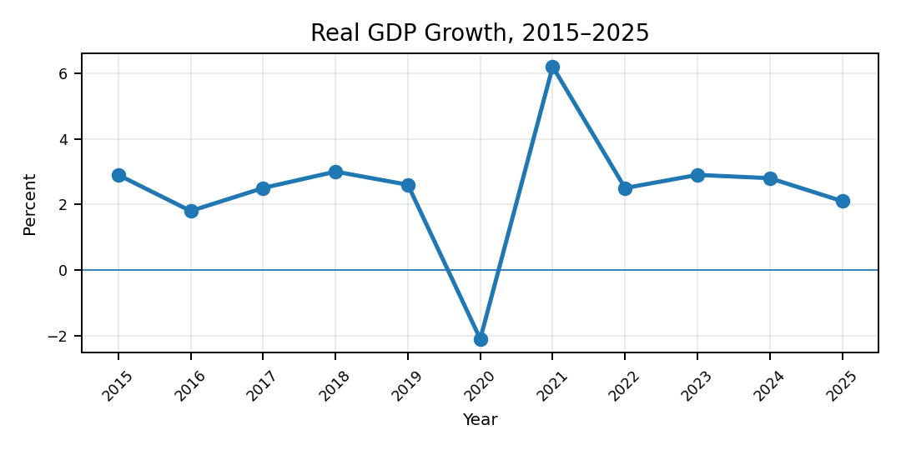
U.S. growth has slowed from the strong recovery seen after 2020, but the economy continues to expand. The recent pattern looks more like a return to normal growth than a sharp downturn.

15 Key Macro Messages
1. Economic Growth: The U.S. economy continues to grow, but the pace has slowed from the strong rebound seen after 2020. The current trend looks more like a return to normal growth than a major slowdown.
2. Consumer Spending: Consumer spending remains one of the main supports for the economy. Households are still spending, although growth in consumption has become more moderate.
3. Inflation: Inflation has come down significantly from its 2022 peak. This has reduced some pressure on household budgets and business costs, although prices are still rising.
4. Core Inflation: Underlying inflation is also moving lower, but the improvement has been gradual. Inflation is becoming more manageable, but it has not completely disappeared as a concern.
5. Interest Rates: Interest rates remain much higher than they were before 2022. Even after some easing, borrowing costs continue to affect households, businesses and investment decisions.
6. Labor Market: The labor market remains relatively strong. Unemployment has increased slightly from recent lows, but there is no sign of a sharp deterioration in employment conditions.
7. Labor Supply: Labor-force participation has recovered from the 2020 decline, although it remains below its earlier peak. Labor availability therefore remains an issue for some industries.
8. Wages: Wage growth has become more moderate as labor-market conditions have started to balance. This may reduce some cost pressure on businesses while continuing to support household income.
9. Housing Market: Housing remains under pressure from high mortgage rates and elevated home prices. Demand has weakened, but limited housing supply continues to provide some support to the market.
10. Business Investment: Companies continue to invest, but the pattern of investment is changing. Technology, automation and digital infrastructure are becoming more important areas of capital spending.
11. AI and Data Centers: Investment in AI and data centers is growing quickly. This is supporting equipment, construction and electricity demand, while grid capacity and power availability are becoming practical constraints.
12. Banking and Credit: Higher interest rates have made borrowing more expensive. Credit conditions remain important for households and businesses, particularly those that need refinancing or new loans.
13. Fiscal Position: The federal budget deficit remains large. Continued high deficits could increase pressure on government borrowing and interest costs over time.
14. Public Debt and External Balance: High public debt and the continuing current-account deficit remain important structural issues. Both increase the importance of stable financial markets and continued investor demand for U.S. assets.
15. Overall U.S. Macro View: The U.S. economy remains in a relatively stable position, with positive growth, lower inflation and a still-resilient labor market. High borrowing costs, fiscal pressure and housing affordability remain important challenges.

Macro Dashboard
These four indicators give a quick view of the main changes in growth, inflation, interest rates and employment.
 | 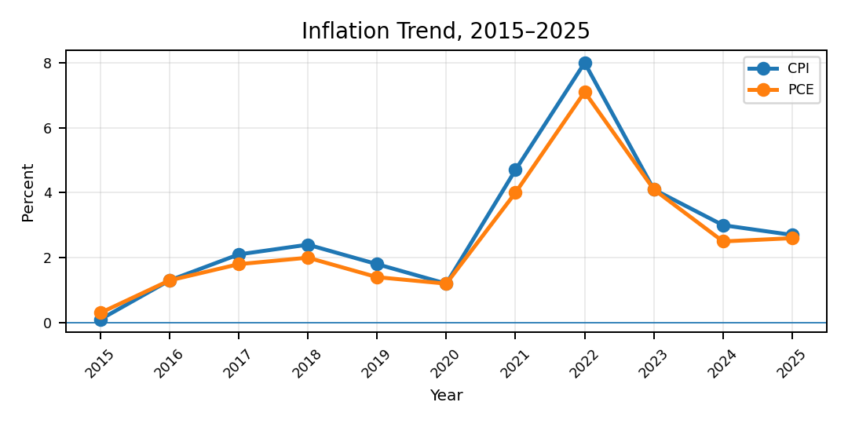
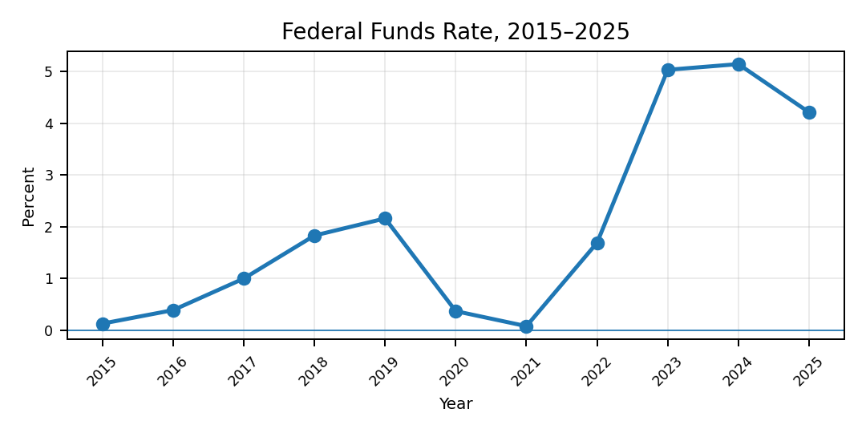 | 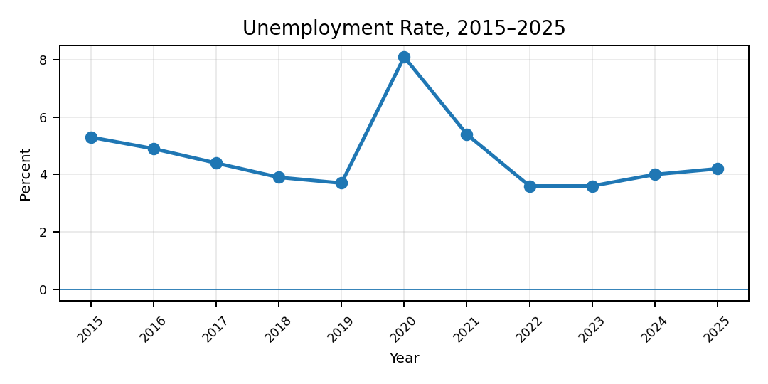
Growth – U.S. economic growth has slowed from the strong recovery seen after 2020, but the economy continues to expand. The trend suggests normalization rather than a sharp loss of momentum.
Inflation – Inflation increased sharply during 2021 and 2022 but has eased considerably since then. Both CPI and PCE inflation moved lower by 2025, improving the overall price environment.
Federal Funds Rate – Interest rates increased rapidly as the Federal Reserve responded to higher inflation. Rates later started to ease, but borrowing costs remain much higher than during the earlier low-rate period.
Labor Market – The labor market recovered strongly after the 2020 disruption. Unemployment remains relatively low, although it has moved slightly higher from the lows seen in 2022 and 2023.
Overall Economic Impact
The main indicators show that the U.S. economy has moved away from the unusual conditions seen between 2020 and 2022. Growth has become more moderate, inflation has fallen and the labor market remains relatively stable. The main pressure now comes from higher borrowing costs, fiscal concerns and weaker affordability in interest-sensitive areas such as housing.
At the same time, investment in technology, AI and infrastructure is creating new sources of economic activity. The overall picture is therefore mixed but relatively stable: the economy is still growing, but businesses and households are operating in a more expensive financial environment.
What to Watch Next
The pace of U.S. economic growth.
Further improvement in CPI and core PCE inflation.
Changes in Federal Reserve interest rates.
Unemployment and job creation.
Consumer spending and household income.
Mortgage rates and housing affordability.
Business investment and credit conditions.
AI and data-center investment.
Federal deficit and government interest costs.
Treasury yields and investor demand.
Current-account and trade developments.
Energy and electricity demand linked to new investment.
Overall Executive View: The U.S. economy is not showing a single dominant weakness. Instead, the outlook reflects a balance between resilient real activity and tighter structural constraints. For businesses and investors, the key issue is how well growth can be maintained while financing costs, fiscal pressure and capacity constraints remain elevated.
Source note: Core historical values use the validated report dataset based on BEA, BLS/FRED, Federal Reserve and CBO series. Fiscal indicators are shown on a fiscal-year basis.

CHAPTER 02 / PAGE 003 / EXECUTIVE SUMMARY

WHAT CHANGED IN 2026?
How the 2026 environment differs from the 2015-2025 period
The U.S. economy entered 2026 after a decade that included steady pre-pandemic growth, a sharp disruption, a strong recovery, an inflation surge and a major change in interest rates. Compared with that period, 2026 looks less like another major turning point and more like a transition toward slower and more balanced conditions.
Growth is continuing, but the economy no longer has the same recovery momentum seen after the pandemic. Inflation is less intense than during the peak years, while borrowing costs remain much higher than they were during most of the earlier decade. The labor market is also becoming more balanced, and businesses are placing greater emphasis on productivity, technology investment and careful capital allocation.
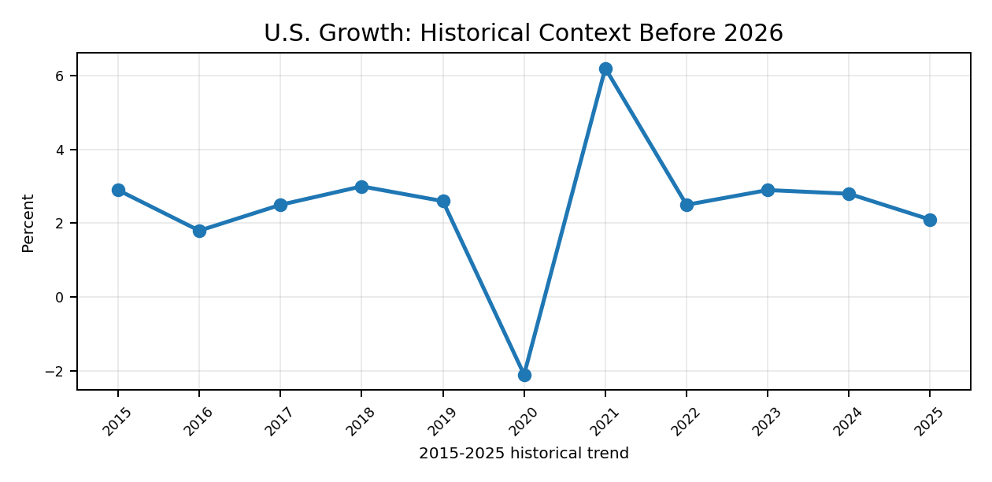
Between 2015 and 2025, U.S. growth moved through a steady expansion, a sharp disruption and a strong recovery. In 2026, the economy appears to be moving into a more moderate phase. Growth is continuing, but the pace is less aggressive than during the recovery years.

Inflation and Interest Rates
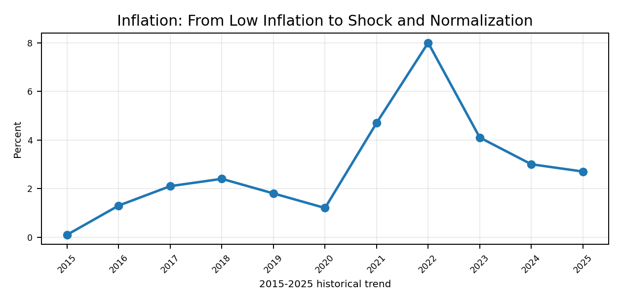 | 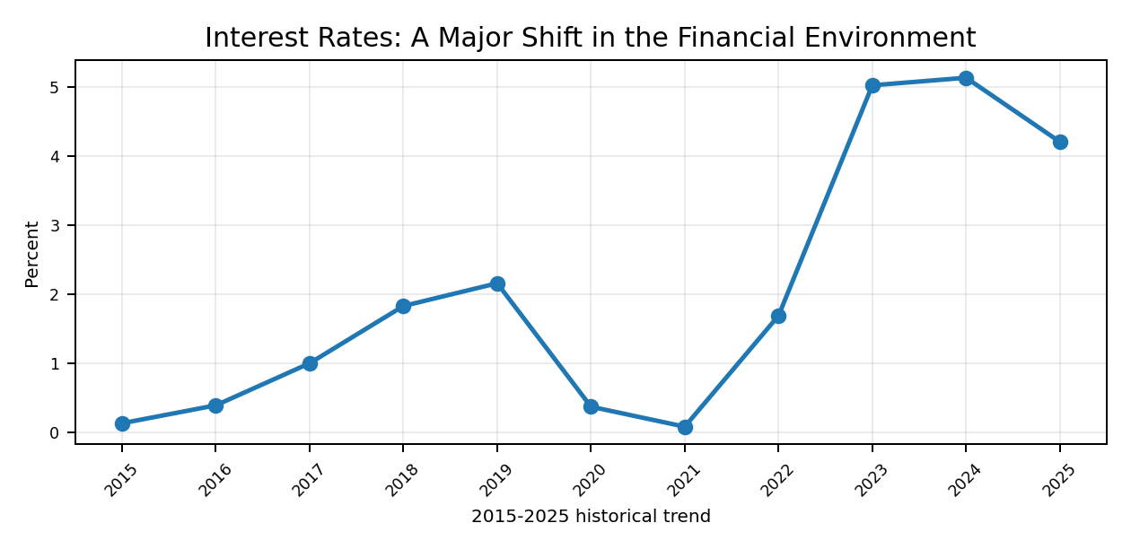
Inflation was relatively contained during much of the period before 2020, increased sharply during the post-pandemic recovery and then gradually eased. In 2026, inflation is no longer the same immediate shock it was a few years earlier, although price stability remains important for households, businesses and monetary policy.
The interest-rate environment has changed significantly compared with most of the 2015-2021 period. Rates moved sharply higher as inflation increased. In 2026, financial conditions are beginning to look less restrictive, but borrowing costs remain well above the earlier low-rate environment.
What This Means in 2026
The combination of lower inflation pressure and still-elevated borrowing costs has changed the way households and companies make financial decisions. Housing, credit and capital-intensive investment remain sensitive to interest rates, while companies with stronger balance sheets are better placed to manage the higher cost of capital.

Labor Market and Broader Economic Shift
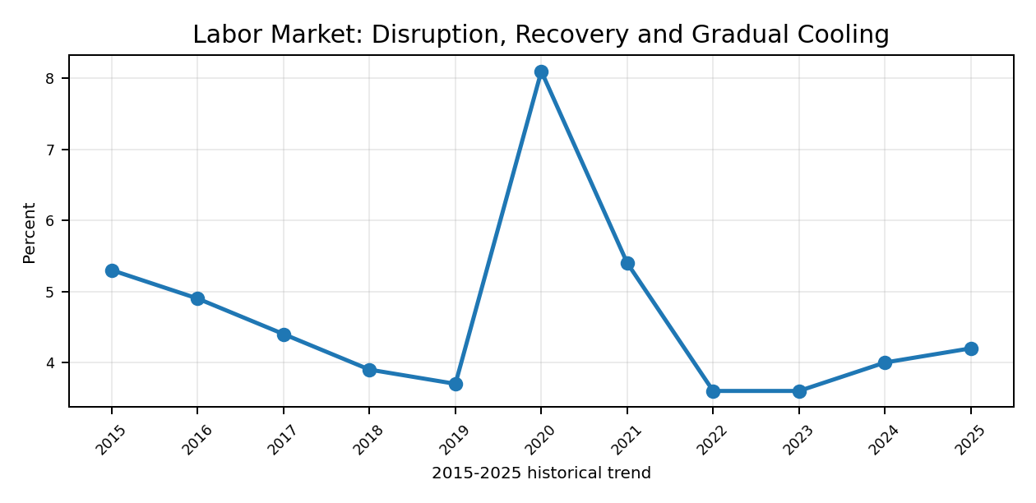
The labor market changed considerably over the 2015-2025 period, moving from steady improvement to a temporary disruption and then a strong recovery. In 2026, conditions look more balanced. Hiring is no longer as strong as during the early recovery period, but the labor market has not shown a major deterioration.
Other Changes Visible in 2026
Consumer Economy: Consumer demand remains an important support to growth, but households are operating in a more expensive borrowing environment than during much of the previous decade.
Housing: Housing remains more constrained by affordability and financing costs than it was during the earlier low-rate years. Limited supply, however, continues to support parts of the market.
Business Investment: Investment is becoming more focused on technology, automation, digital infrastructure and projects that can improve productivity.
AI and Data Centers: AI-related investment is becoming more visible across technology, construction, electricity and infrastructure. The opportunity is growing, but power and grid capacity are becoming practical constraints.
Fiscal Position: Fiscal pressure is more significant than it was in the middle of the last decade. Government borrowing and interest costs now play a larger role in the broader macroeconomic outlook.
Trade and Policy: Trade policy has become a more important source of uncertainty for companies with global supply chains, imported inputs or international exposure.
Financial Conditions: The cost of capital remains a bigger consideration than it was during the earlier low-rate period, making financing structure and investment discipline more important.
Overall Inference
Compared with the 2015-2025 period, 2026 is best viewed as a year of adjustment rather than a completely new economic cycle. The economy is still growing, inflation pressure has eased and employment remains relatively stable, but the environment is more demanding because borrowing costs, fiscal pressure and policy uncertainty remain elevated.
The biggest difference from the earlier part of the decade is that businesses can no longer rely on very low financing costs. At the same time, technology and AI-related investment are opening new areas of growth. This makes productivity, balance-sheet strength and careful capital allocation more important in 2026.
Source note: Historical chart context is based on official U.S. macroeconomic series from BEA, BLS and the Federal Reserve. The written inferences focus on direction and change rather than repeating chart values.

CHAPTER 02 / PAGE 004 / EXECUTIVE SUMMARY

WHAT MATTERS FOR 2027?
Key Outlook Drivers | Executive View
The main issue for 2027 is whether the U.S. economy can keep growing as the effects of earlier policy changes, high financing costs and slower labor-force growth continue to work through the system. The outlook is not centered on one single risk. It depends on how growth, inflation, interest rates, consumer demand and investment develop together.
Compared with the post-pandemic period, 2027 is likely to be more about the quality of growth than the speed of growth. Productivity, technology investment and business efficiency will matter more, while companies will still need to manage borrowing costs, trade uncertainty and fiscal pressure.
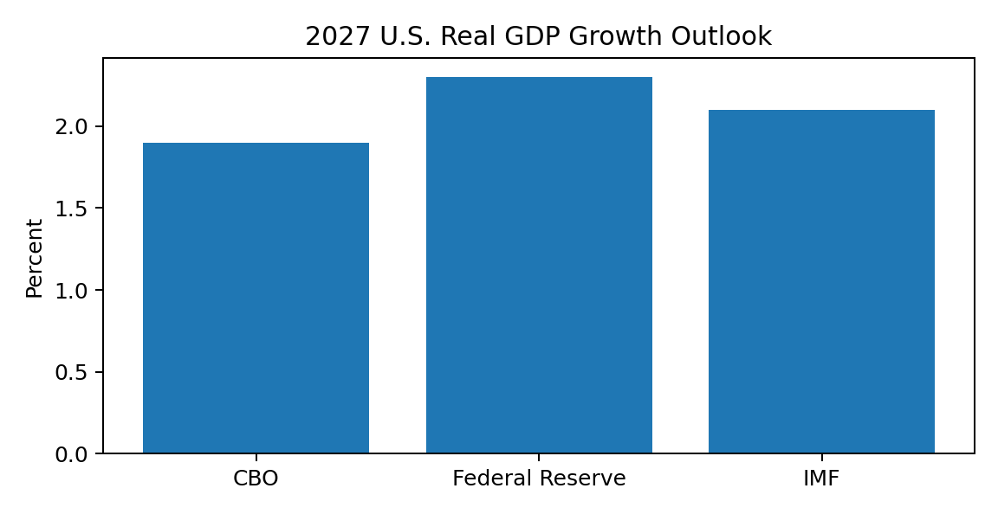
Major institutions continue to expect U.S. growth in 2027, although the exact pace differs across forecasts. The common message is that the economy is expected to expand at a moderate rate rather than return to the unusually strong rebound seen earlier in the decade.

Key Outlook Drivers
Growth and Consumer Demand: Consumer spending will remain important, but the outlook will depend on whether household income and employment can continue to support demand as borrowing costs stay relatively high.
Inflation: Further improvement in inflation would make the overall environment easier for households and businesses. Persistent price pressure, however, could delay a fuller normalization in financial conditions.
Federal Reserve Policy: The direction of interest rates will remain one of the biggest influences on housing, credit, corporate investment and financial markets. The pace of policy easing matters as much as the final level of rates.
Labor Market: A gradual cooling in employment would be manageable if job losses remain limited. A sharper weakening would affect consumer demand, while continued labor-supply constraints could keep wage pressure elevated.
Housing and Credit: Housing activity has room to improve if financing conditions become easier, but affordability and supply remain important constraints. Credit quality and refinancing conditions will also matter for households and companies.
Fiscal and Treasury Conditions: Large federal borrowing needs will keep debt, interest costs and Treasury-market conditions in focus. Higher long-term yields could offset some of the benefit from easier short-term monetary policy.
Trade and Policy: Tariffs and other trade-policy changes remain important for import costs, supply chains and business planning. Greater policy stability would make investment decisions easier.
AI, Data Centers and Productivity: Technology investment remains one of the clearest opportunities. AI and data-center expansion can support equipment, construction and productivity, but the scale of investment increasingly depends on electricity and infrastructure capacity.

Technology, Energy and Infrastructure
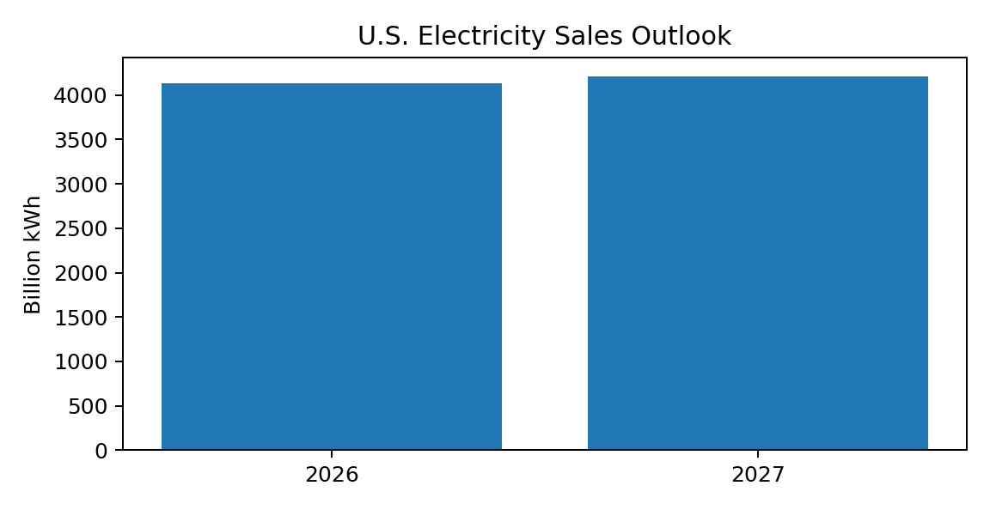
Electricity demand is expected to keep rising in 2027, with data centers and manufacturing among the main drivers. This creates opportunities for utilities, power generation, grid investment and electrical equipment, but it also shows that infrastructure capacity could become a limit on how quickly new projects are developed.
AI investment is therefore becoming more than a technology-sector story. The next stage of expansion is increasingly linked to power availability, grid connections, construction capacity and suitable locations. Companies that can solve these infrastructure constraints may benefit alongside the technology firms making the original investment.

Risk / Opportunity Matrix
Outlook Driver | Risk | Opportunity | What to Watch
Economic Growth | Growth loses more momentum than expected. | Stable demand supports a soft-landing style expansion. | Consumer spending, business activity and investment.
Inflation | Price pressure remains sticky or rises again. | Further disinflation improves purchasing power and financial conditions. | Core inflation, services prices and energy costs.
Interest Rates | Rates stay high for longer or long-term yields rise. | Gradual easing improves housing, credit and investment conditions. | Fed policy, Treasury yields and lending rates.
Labor Market | Hiring weakens sharply and unemployment rises. | A balanced labor market supports incomes without excessive wage pressure. | Payrolls, unemployment and wage growth.
Fiscal Position | Heavy borrowing keeps pressure on yields and interest costs. | Stronger growth and revenue performance improve fiscal outcomes. | Deficit, debt service and Treasury issuance.
Trade Policy | Tariffs raise costs and disrupt supply chains. | Greater policy clarity supports planning and domestic investment. | Tariffs, import prices and trade flows.
AI / Data Centers | Power, land and grid constraints delay projects. | Strong investment supports technology, construction, power and productivity. | Data-center capex, electricity load and grid projects.
Energy | Energy-price shocks add to inflation and business costs. | Strong domestic supply supports investment and energy security. | Oil, natural gas, electricity and generation capacity.

2027 Executive Outlook
The 2027 outlook is likely to depend on whether lower inflation and gradually easier financial conditions can support demand without creating another round of price pressure. Growth does not need to be unusually strong for the environment to remain constructive. A steady expansion, stable employment and improving financing conditions would be enough to support many parts of the economy.
The main risks come from persistent inflation, high long-term interest rates, fiscal pressure, trade-policy uncertainty and a sharper weakening in employment. The strongest opportunities are linked to technology, AI, data centers, power infrastructure and productivity improvement.
For businesses, 2027 is likely to reward companies that can protect margins, manage financing carefully and invest in areas that improve productivity. For investors, the key question is whether earnings and economic growth can remain stable as the economy adjusts to a higher-cost capital environment.

Overall Inference
What matters most for 2027 is not whether the economy returns to the conditions of the previous decade. The more important question is whether the U.S. can maintain moderate growth while inflation continues to improve and investment shifts toward technology and infrastructure. If that balance holds, the outlook remains supportive. If inflation, interest rates or policy uncertainty stay elevated for longer, growth could become more uneven.

Source Notes
- Congressional Budget Office, The Budget and Economic Outlook: 2026 to 2036 (February 2026).
- Federal Reserve, Summary of Economic Projections (March 2026).
- International Monetary Fund, 2026 Article IV Consultation with the United States.
- U.S. Energy Information Administration, Short-Term Energy Outlook (September 2026).
Forecast status: 2027 values are projections, not historical observations. The written discussion focuses on the direction of the outlook rather than repeating forecast numbers.

BrandEssence Economic Intelligence | Executive | 4

CHAPTER 03 / PAGE 005 / U.S. MACRO DASHBOARD

3. U.S. Macro Dashboard
Executive KPI Dashboard | 2015–2025 historical overview
The dashboard brings together the main indicators shaping the U.S. economy through 2025. Growth remains positive but has moderated, inflation has eased from its earlier peak, and the labor market is less tight than during the post-pandemic rebound. At the same time, elevated borrowing costs and a heavier public-debt burden continue to influence household, corporate and government financial decisions.
Real GDP Growth  1.5%  Q2 2026, annualized | CPI Inflation  3.4%  Jul 2026, y/y | Core CPI  2.5%  Jul 2026, y/y | PCE Inflation  3.7%  Jul 2026, y/y
Core PCE  3.3%  Jul 2026, y/y | Unemployment  4.1%  Aug 2026 | Payroll Change  +162k  Aug 2026 | Personal Income  +0.4%  Jul 2026, m/m
Real PCE  ~0.0%  Jul 2026, m/m | Saving Rate  3.0%  Jul 2026 | FY2026 Deficit  5.8% GDP  CBO baseline | Public Debt  101% GDP  FY2026 CBO baseline

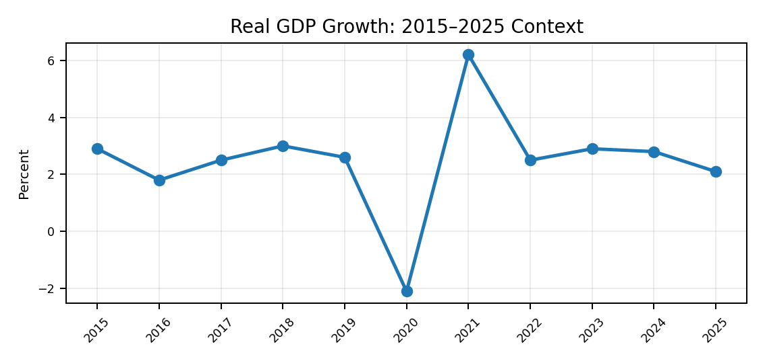 | 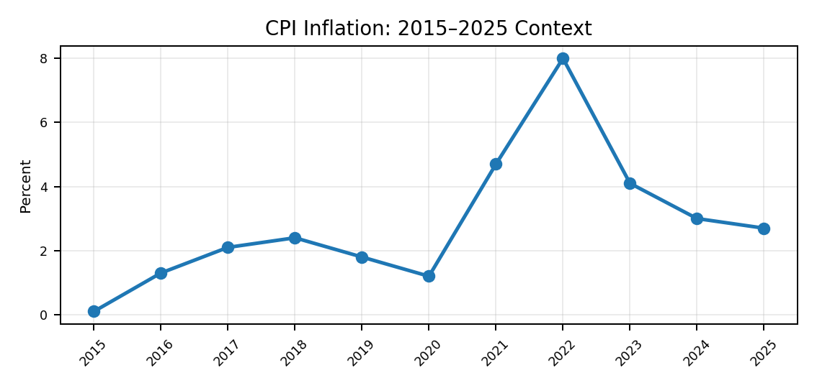
Growth has moved back toward a more moderate pace after the large swings seen earlier in the decade. The economy is still expanding, but slower momentum has reduced the pace of demand growth across consumer spending, hiring and business expansion. For U.S. companies, this means revenue growth is becoming more dependent on productivity and market-share gains rather than unusually strong economy-wide demand; for households, it points to a more cautious spending environment without yet signalling a broad contraction.
Inflation is well below the earlier peak, easing part of the pressure on household purchasing power and business input costs. The improvement has helped real incomes recover, but persistent underlying price pressure has limited the speed at which interest rates can normalize. As a result, housing affordability, consumer credit and capital-intensive investment remain more constrained than they were in the pre-2020 low-rate environment.

30-Indicator Macro Dashboard
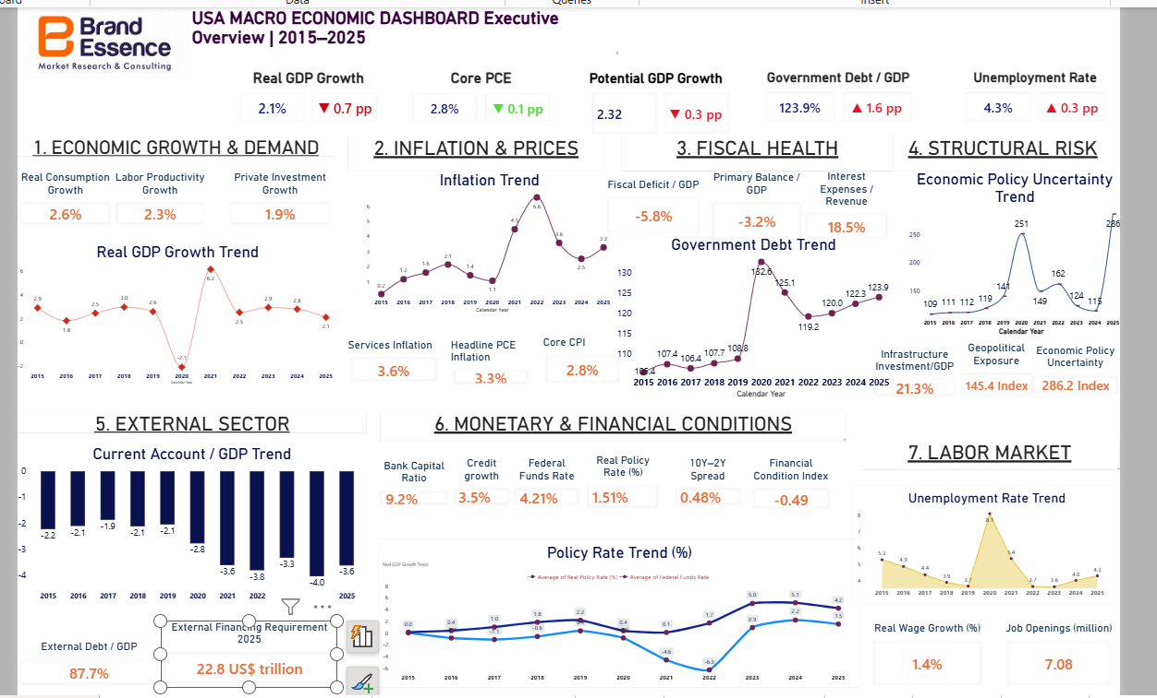
Figure: USA Macroeconomic Dashboard - Executive Overview | 2015–2025
Area | Indicator | Latest / Reference | Period | Dashboard Signal
Growth | Real GDP growth | 1.5% | Q2 2026 annualized | Positive, slower
Growth | Q1 real GDP growth | 2.1% | Q1 2026 annualized | Previous quarter
Consumer | Personal consumption expenditure | +0.2% | Jul 2026 m/m | Positive
Consumer | Real PCE | <0.1% | Jul 2026 m/m | Soft
Income | Personal income | +0.4% | Jul 2026 m/m | Positive
Income | Disposable personal income | +0.5% | Jul 2026 m/m | Positive
Savings | Personal saving rate | 3.0% | Jul 2026 | Low
Inflation | CPI | 3.4% | Jul 2026 y/y | Elevated
Inflation | Core CPI | 2.5% | Jul 2026 y/y | Moderating
Inflation | PCE price index | 3.7% | Jul 2026 y/y | Elevated
Inflation | Core PCE | 3.3% | Jul 2026 y/y | Sticky
Inflation | Monthly PCE | +0.2% | Jul 2026 m/m | Moderate
Labor | Unemployment rate | 4.1% | Aug 2026 | Stable
Labor | Nonfarm payroll change | +162k | Aug 2026 | Improved
Labor | Average hourly earnings | $37.62 | Jul 2026 | Firm
Labor | Hourly earnings growth | 3.2% | Jul 2026 y/y | Moderating
Labor | Average private workweek | 34.3 hrs | Jul 2026 | Stable
Prices | PPI final demand | 0.0% | Jul 2026 m/m | Flat
Prices | Import prices | -0.4% | Jul 2026 m/m | Lower
Prices | Export prices | -1.3% | Jul 2026 m/m | Lower
Labor costs | Employment Cost Index | +0.9% | Q2 2026 q/q | Firm
External | Current account / GDP | -3.6% | 2025 annual | Deficit
Monetary | Effective fed funds rate | 4.21% | 2025 annual avg. | High vs 2010s
Monetary | Real policy rate | 1.61% | 2025 derived | Restrictive
Fiscal | Federal deficit | $1.9T | FY2026 CBO baseline | High
Fiscal | Federal deficit / GDP | 5.8% | FY2026 CBO baseline | High
Fiscal | Debt held by public | 101% GDP | FY2026 CBO baseline | High
Fiscal | Federal outlays | $7.4T | FY2026 CBO baseline | High
Fiscal | Federal revenues | $5.6T | FY2026 CBO baseline | Firm
Fiscal | Net interest / GDP | 3.3% | FY2026 CBO baseline | Elevated
Dashboard note: Monthly, quarterly, annual and fiscal-year indicators are labelled separately. The dashboard uses the latest reliable reading where available and keeps structural annual indicators as reference measures.

Rates and Labor: Economic Impact
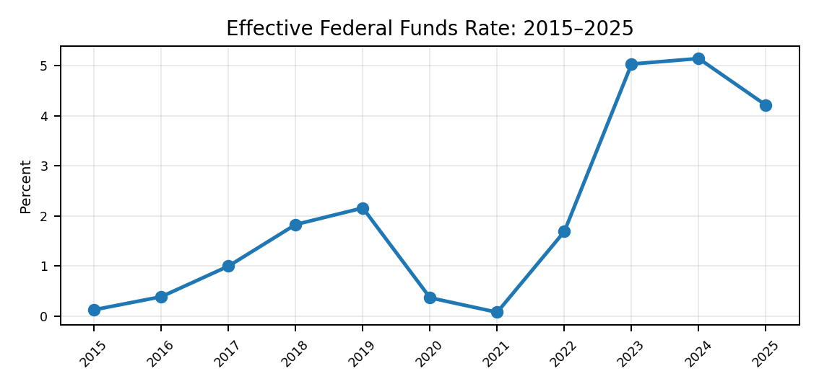 | 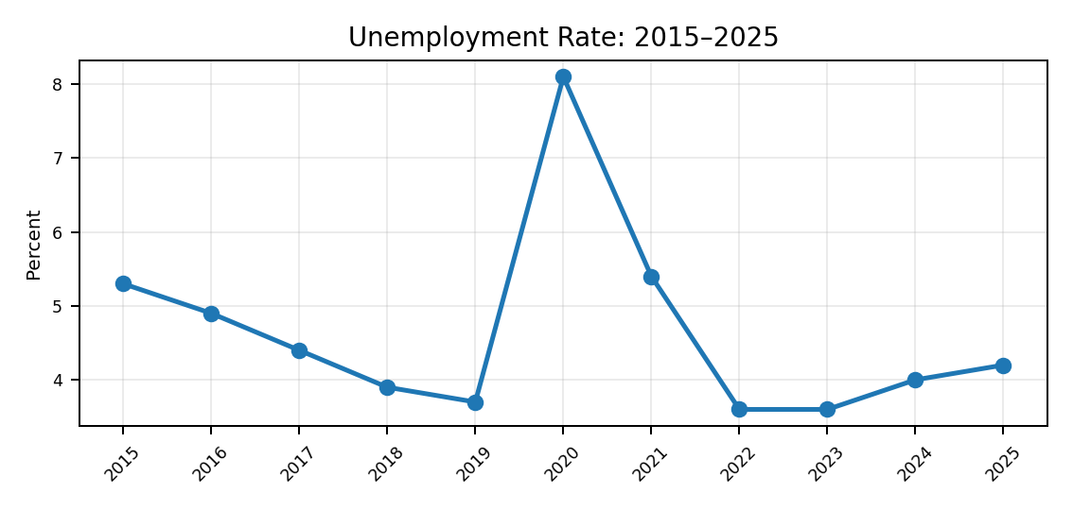
The interest-rate environment remains much tighter than the low-rate conditions that dominated much of the earlier period. Higher financing costs have reduced housing affordability, raised corporate hurdle rates and made refinancing more expensive for households, businesses and the federal government. This has shifted investment toward projects with stronger expected returns and kept interest-sensitive demand from accelerating as quickly as overall activity.
The labor market has moved toward more balanced conditions after the unusually tight post-pandemic period. Employment and wage income are still supporting household consumption, but softer hiring and fewer vacancies have reduced workers’ bargaining power and eased some wage pressure on employers. That combination supports disinflation, while a further weakening in labor demand would begin to weigh more directly on consumer spending and confidence.

How the Movements Affect the U.S. Economy
Growth & Consumer: Activity remains positive, but slower growth means household demand is providing less acceleration than during the rebound. This reduces the lift to retail, discretionary services and revenue growth, while keeping the expansion dependent on continued income gains and employment stability.
Inflation: Lower inflation has improved real purchasing power and reduced part of the cost pressure facing businesses. However, incomplete disinflation keeps monetary policy relatively restrictive, which continues to affect mortgages, consumer credit and corporate financing.
Labor: A more balanced labor market is reducing recruitment pressure and wage-cost acceleration for employers, while still generating enough income to support consumption. A sharper rise in unemployment would weaken that support and increase downside risk to household demand.
Monetary Conditions: Higher rates continue to raise mortgage payments, corporate borrowing costs and investment hurdle rates. This has slowed interest-sensitive demand and encouraged firms to prioritise higher-return projects, even as credit remains available.
Fiscal Position: Large borrowing needs and rising interest costs absorb a greater share of public resources and increase Treasury supply. That can keep upward pressure on longer-term yields, reinforcing financing costs across mortgages, business loans and investment markets.
External Position: The current-account deficit keeps the U.S. reliant on sustained global demand for dollar assets. Strong capital inflows help finance domestic spending and government borrowing, while weaker foreign demand would increase pressure on yields and the dollar.

Overall Economic Impact
The dashboard does not point to a single dominant weakness. Instead, it shows an economy that is still expanding while adjusting to higher inflation and financing costs than were common before 2020. The strongest support continues to come from employment, income and private demand. The main pressures are inflation, interest-sensitive activity and the fiscal position.

Source Notes
- U.S. Bureau of Economic Analysis — GDP and Personal Income and Outlays.
- U.S. Bureau of Labor Statistics — CPI, Employment Situation, earnings, PPI, import/export prices and ECI.
- Federal Reserve — monetary-policy and effective federal funds rate series.
Congressional Budget Office — FY2026 budget baseline and debt projection

CHAPTER 04 / PAGE 006 / BRANDESSENCE U.S. MACRO VIEW

4. THE BRANDESSENCE U.S. MACRO VIEW
Proprietary Interpretation | What BrandEssence believes the data means
BrandEssence sees the U.S. economy moving into a more selective phase of growth. The broad post-pandemic rebound has largely passed, but this does not necessarily point to a weak economic cycle. Growth is becoming more dependent on productivity, technology investment and the ability of households and businesses to operate effectively in a higher-cost financial environment.
Our view is that the U.S. still has meaningful economic resilience. Consumer demand and employment continue to provide support, while technology, AI and infrastructure investment are creating a new source of capital spending. At the same time, fiscal pressure, long-term borrowing costs and policy uncertainty have become more important constraints than they were during the earlier low-rate period.

BrandEssence Core Macro View
Growth: Resilient, but more moderate. The economy can continue to expand without returning to the unusually strong recovery pace.
Consumer: Still supportive, but more selective. Affordability and credit costs are playing a larger role in spending decisions.
Labor Market: Cooling rather than collapsing. A more balanced labor market can reduce wage pressure without creating a major demand shock.
Inflation: Improving, but not fully resolved. The direction is better, although price stability still matters for rates and confidence.
Monetary Conditions: Less restrictive over time, but not a return to the old low-rate environment. Financing discipline remains important.
Fiscal Position: The clearest structural vulnerability. Persistent deficits and interest costs can keep pressure on long-term yields.
Financial System: Broadly resilient, although refinancing risk and pockets of credit stress still need to be watched.
Technology & Productivity: The strongest medium-term opportunity. AI, data centers, automation and infrastructure can support investment and productivity.

BrandEssence U.S. Macro Resilience Wheel
The wheel summarizes BrandEssence's internal view of the main forces supporting or constraining the U.S. economy. A higher score represents greater resilience or a stronger structural opportunity. These are proprietary assessment scores, not official statistics.
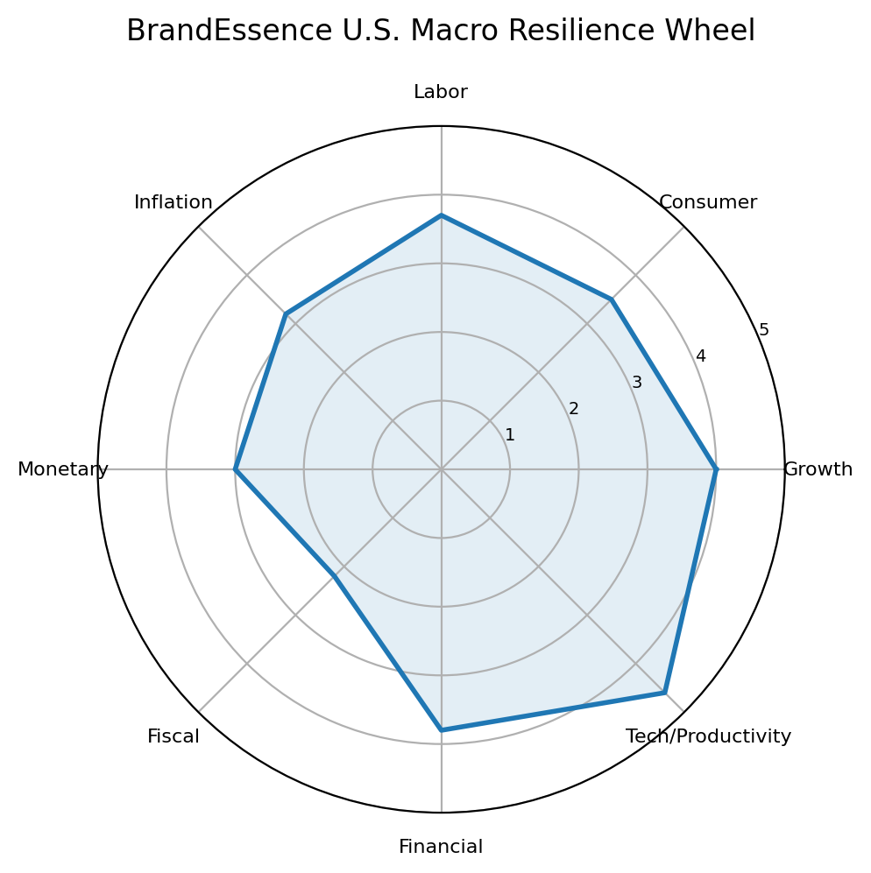
Technology and productivity stand out as the strongest part of the current macro picture, supported by relatively resilient growth and a still-functional financial system. Fiscal conditions are the weakest area because persistent deficits and higher interest costs create a longer-term constraint. Inflation and monetary conditions sit between these two extremes: both have improved, but neither has fully returned to the environment that existed before the pandemic.

BrandEssence Resilience Scores
Dimension | Score / 5 | BrandEssence Reading
Growth | 4.0 | Resilient
Consumer | 3.5 | Moderately resilient
Labor | 3.7 | Stable / cooling
Inflation | 3.2 | Improving
Monetary | 3.0 | Still restrictive
Fiscal | 2.2 | Vulnerable
Financial | 3.8 | Relatively resilient
Tech/Productivity | 4.6 | Strong opportunity

Where BrandEssence Is Positive
AI and Data Centers: The investment cycle is spreading beyond software and semiconductors into construction, power, cooling, networking and grid infrastructure.
Productivity: Wider adoption of AI and automation creates a path for firms to improve efficiency even when labor and financing costs remain higher.
Private-Sector Adaptability: U.S. companies have repeatedly adjusted to changing demand, supply conditions and financing costs, supporting overall resilience.
Infrastructure Investment: Power generation, transmission, electrical equipment and digital infrastructure are becoming more important parts of the investment story.
Selective Consumer Strength: Household demand is not uniformly strong, but employment and income continue to provide a base for spending in many categories.

Where BrandEssence Is Cautious
Fiscal Pressure: Large deficits and higher interest costs could keep long-term borrowing conditions tighter than businesses and households would prefer.
Long-Term Interest Rates: Even if short-term policy rates ease, Treasury yields may remain sensitive to inflation, debt issuance and investor demand.
Housing Affordability: Mortgage costs and home prices continue to make housing one of the most interest-sensitive parts of the economy.
Trade and Policy Uncertainty: Changes in tariffs and other policy settings can affect costs, supply chains and the timing of business investment.
Uneven Credit Conditions: The financial system is broadly stable, but highly leveraged borrowers and refinancing-dependent sectors remain more exposed.

BrandEssence Macro View
BrandEssence does not view the current U.S. environment as a simple slowdown story. The economy is adjusting to higher financing costs, a larger fiscal burden and a more uncertain policy environment, but it continues to benefit from strong private-sector capacity and a new investment cycle linked to technology and infrastructure.
In our view, the main opportunity lies in productivity-led growth. The main risk comes from the interaction of fiscal pressure, long-term interest rates and persistent inflation. If inflation continues to improve without a major deterioration in employment, the economy should remain capable of moderate expansion. If fiscal and financing pressures intensify at the same time, growth could become more uneven.

Methodology Note
The BrandEssence Macro Resilience Wheel is a proprietary qualitative framework. Scores range from 1 to 5, where a higher score indicates greater resilience or a stronger structural opportunity. The assessment combines official macroeconomic evidence with BrandEssence's interpretation of direction, persistence and economic impact. The scores should not be read as government statistics or a third-party credit rating.
External context: Congressional Budget Office, The Budget and Economic Outlook: 2026 to 2036; Federal Reserve, June 2026 Summary of Economic Projections.

CHAPTER 05 / PAGE 007 / GLOBAL ECONOMY & U.S. POSITION

GLOBAL ECONOMY: STARTING POINT
World Growth and Inflation | Global Context for the U.S. Outlook
The global economy entered 2026 with reasonable momentum, but the environment became more difficult as energy-market disruption and geopolitical uncertainty added new pressure to prices and confidence. At the same time, technology-related investment has remained a source of support, especially in economies connected to the AI and digital infrastructure cycle.
The result is an uneven global picture rather than a synchronized downturn. Growth remains stronger in parts of Asia and several emerging markets, while many advanced economies are expanding more slowly. For the United States, this matters through trade demand, energy prices, financial conditions, supply chains and capital flows.
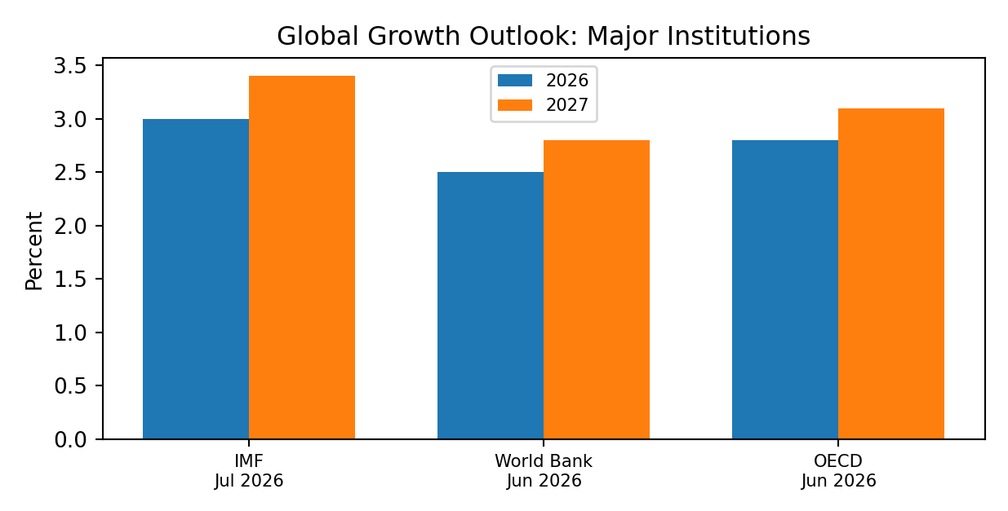
The major institutions differ on the exact pace of global growth, but they tell a similar story. 2026 is expected to be softer than the stronger momentum seen before the latest energy shock, while 2027 is generally expected to improve. The gap between forecasts also shows how sensitive the outlook remains to assumptions about geopolitics, energy markets and policy.

A More Uneven Global Growth Map
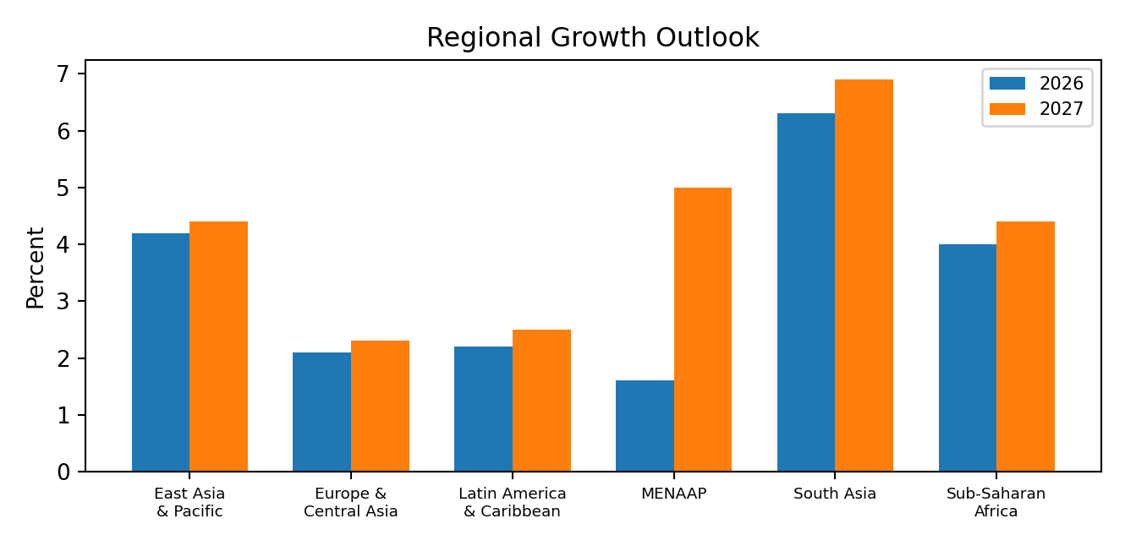
Growth is increasingly uneven across regions. South Asia remains the fastest-growing major region in the World Bank outlook, while Europe and Latin America are expanding at a more modest pace. The Middle East outlook shows the largest expected rebound into 2027, reflecting the assumed recovery from the 2026 conflict-related disruption. This uneven pattern means global demand will not provide the same support to every industry or export market.

World Map – How to Read the Global Starting Point
For the report's world-map visual, countries and regions should be grouped by growth momentum rather than treated as if the global cycle is uniform. Asia should appear as the main growth engine, Europe as a slower-growth region, and energy-sensitive economies should be highlighted separately because their outlook is more exposed to commodity and geopolitical developments.
Asia: Remains the main source of global growth, supported by large domestic markets, manufacturing and technology-linked investment.
Europe: Growth remains comparatively modest and more sensitive to energy costs, external demand and financial conditions.
Middle East: The 2026 shock has weakened near-term activity, but the outlook can change quickly if energy-market disruption fades.
Latin America: Growth remains positive but moderate, with commodity conditions, domestic policy and financing costs playing an important role.
Sub-Saharan Africa: Growth remains relatively firm, although financing conditions, food and energy costs and country-specific vulnerabilities remain important.
United States: The U.S. remains central to global demand and financial conditions, but its outlook is increasingly linked to domestic investment, technology and the path of inflation and interest rates.

Global Inflation: Progress Has Become Less Smooth
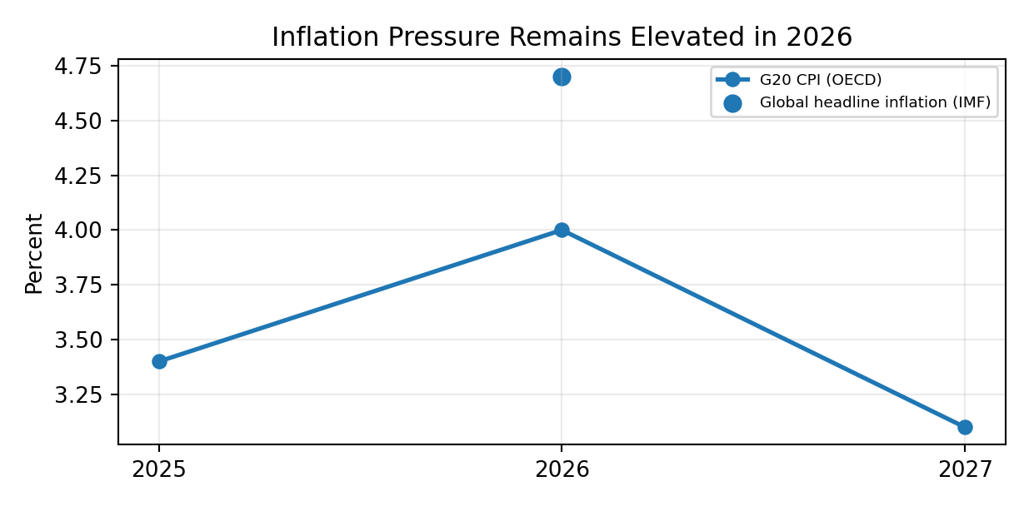
The earlier global disinflation trend has become less straightforward in 2026. Higher energy costs have pushed headline inflation higher again in many economies, even where underlying price pressure is more contained. If energy pressures fade, inflation should improve into 2027, but another commodity shock would make the path more difficult.

What the Global Starting Point Means for the U.S.
External Demand: Slower global growth can limit export demand, while stronger Asian growth creates more selective opportunities.
Energy and Inflation: Global energy shocks can quickly feed into U.S. inflation, transport costs and household purchasing power.
Interest Rates: Persistent global inflation can keep monetary policy and bond yields higher for longer across major economies.
Dollar and Capital Flows: Differences in growth and interest rates influence the dollar and international demand for U.S. financial assets.
Technology Cycle: The global AI investment boom is supporting semiconductor, data-center and infrastructure demand, creating an important counterweight to weaker traditional growth drivers.
Geopolitical Risk: Trade routes, commodity markets and supply chains remain exposed to geopolitical developments, making resilience and diversification more important for businesses.

Overall Inference
The global economy is starting from a position of moderate but uneven growth. The main challenge is that inflation pressure has become more sensitive to energy and geopolitical events, while the main source of upside is the continued technology-investment cycle. For the U.S., the global backdrop is therefore neither clearly supportive nor clearly negative. It creates a mix of weaker external demand, inflation risk and strong technology-related investment opportunities.
Sources: IMF World Economic Outlook Update, July 2026; World Bank Global Economic Prospects, June 2026; OECD Economic Outlook, June 2026. Forecasts are projections and differ because the institutions use different assumptions and methodologies.

CHAPTER 05 / PAGE 008 / GLOBAL ECONOMY & U.S. POSITION

8. U.S. POSITION IN THE GLOBAL ECONOMY
GDP, Trade and Capital | Country Comparison
The United States remains one of the strongest large advanced economies in the current global cycle. Its growth outlook is stronger than most major advanced peers, while the economy also benefits from deep capital markets, large inward and outward investment positions and the global role of the dollar. At the same time, the U.S. runs a persistent current-account deficit, which means foreign capital continues to play an important role in financing the economy.
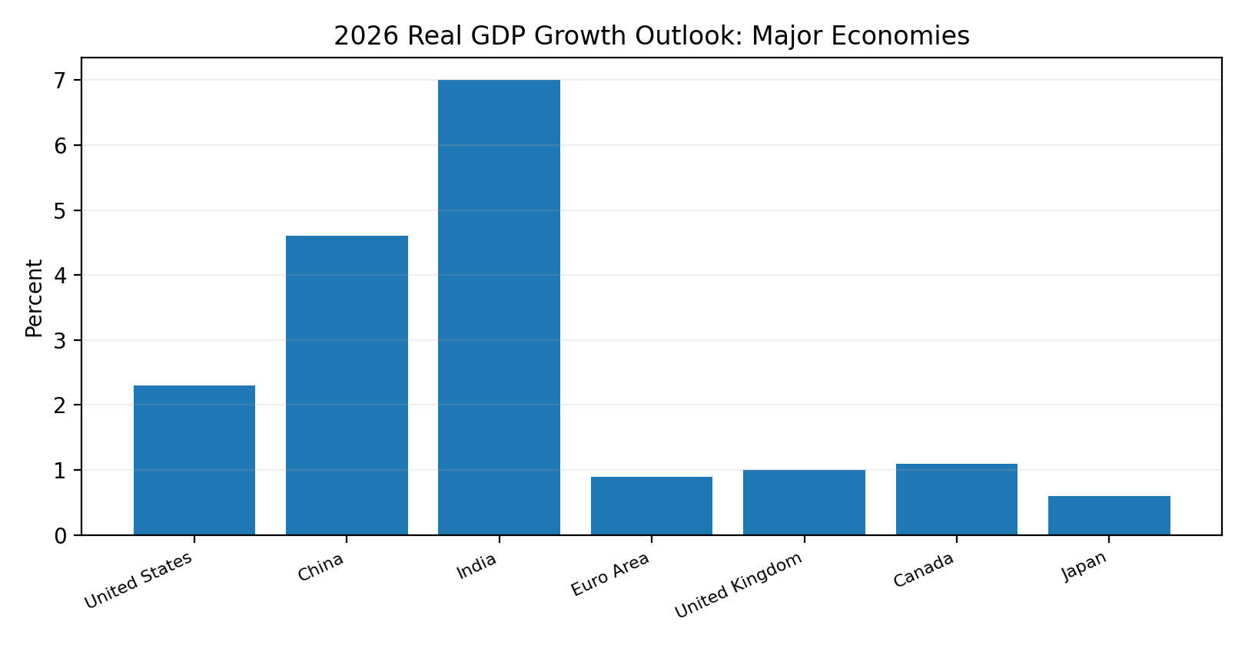
The comparison shows a clear split between advanced and emerging economies. The U.S. is growing faster than most large advanced peers, but remains well below the pace expected in India and China. This places the U.S. in a relatively strong position among developed markets without making it the fastest-growing major economy.
Source: IMF, World Economic Outlook Update, July 2026.

Trade and Capital Position
Indicator | Latest Position | What It Shows | Implication
Current-account balance | Deficit equal to 2.9% of GDP in Q1 2026 | The U.S. imports more capital and resources from abroad than it supplies on net. | Stable foreign demand for U.S. assets remains important.
Net international investment position | -$21.27 trillion at end-Q1 2026 | Foreign claims on U.S. assets exceed U.S. claims on foreign assets. | The U.S. remains deeply integrated with global capital markets.
U.S. direct investment abroad | $7.14 trillion at end-2025 | U.S. companies have a large global production and investment footprint. | Overseas earnings and global demand remain important for U.S. firms.
Foreign direct investment in U.S. | $5.86 trillion at end-2025 | The U.S. remains a major destination for long-term foreign capital. | Manufacturing and technology investment support domestic capacity.
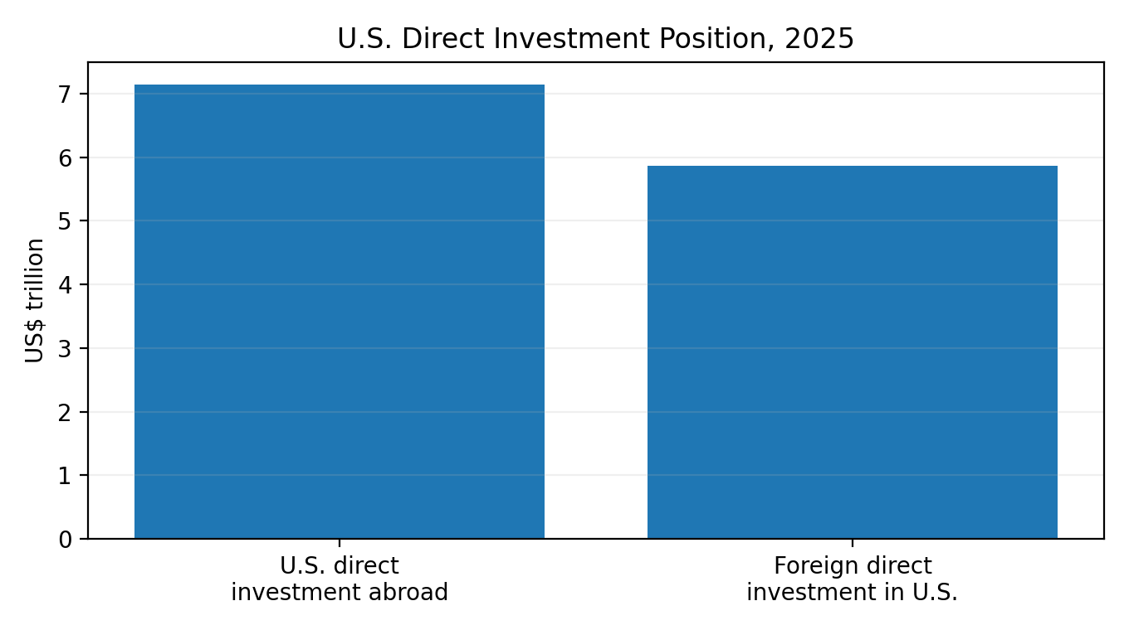
The United States is both a major exporter and importer of long-term capital. U.S. companies hold a very large stock of investment abroad, while foreign companies continue to commit substantial capital to the U.S. economy. This two-way investment relationship is a major source of economic integration and business resilience.
Source: U.S. Bureau of Economic Analysis, International Transactions and Direct Investment releases, 2026.

9. GLOBAL INTEREST RATE ENVIRONMENT
Fed vs ECB, Bank of Japan, Bank of England and Reserve Bank of Australia
Global monetary policy is no longer moving in one direction. Central banks are responding to different combinations of inflation, growth and energy risk. The Federal Reserve and Bank of England remain relatively restrictive, the Bank of Japan continues to normalize from a very low starting point, and the ECB has moved back toward tighter policy as energy-related inflation pressure returned.
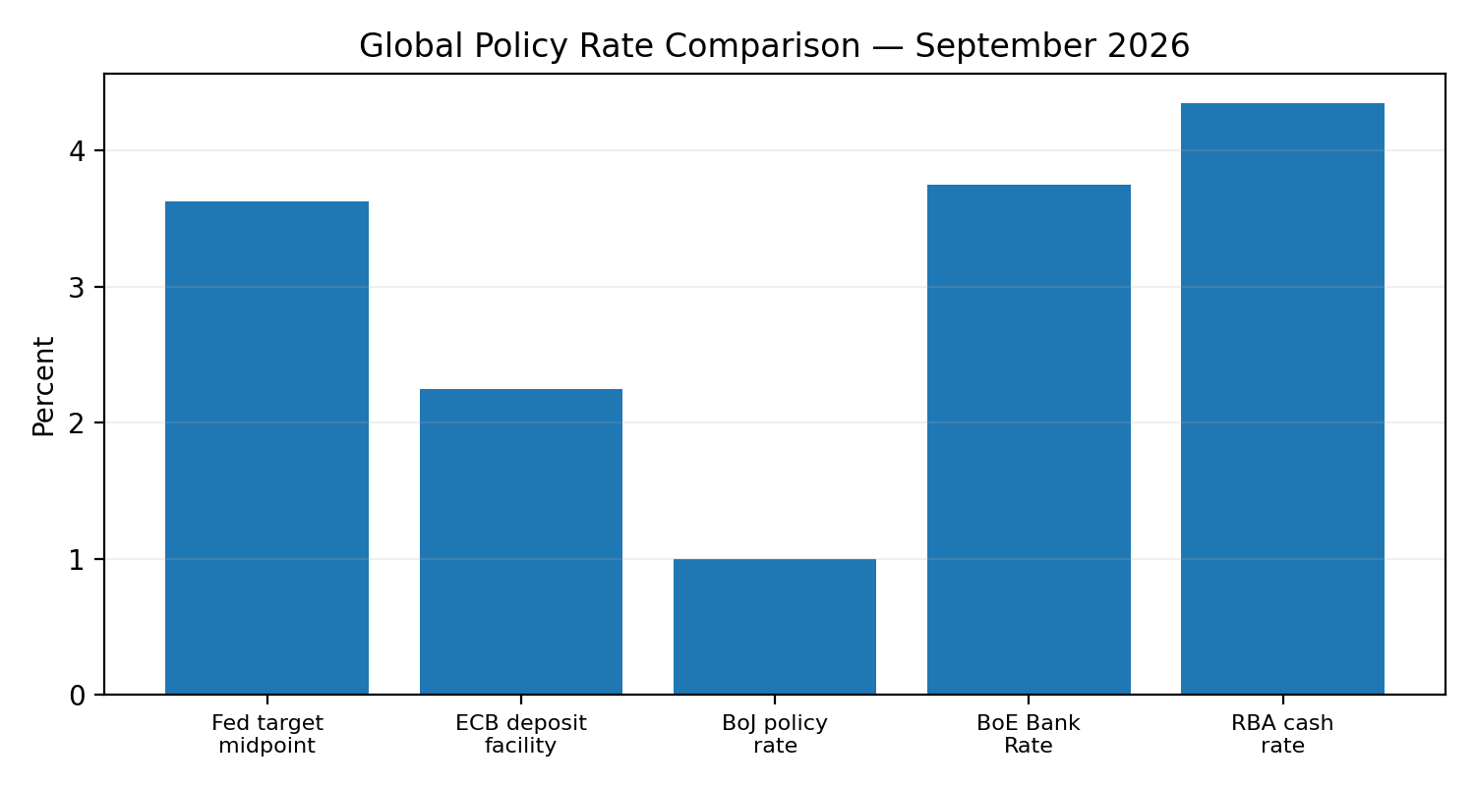
Policy rates remain meaningfully different across major economies. The U.S. and U.K. are still operating with relatively high rates, while Japan remains much lower despite gradual normalization. The gap between policy settings affects exchange rates, global capital flows and the relative attractiveness of U.S. financial assets.
Source: Federal Reserve (July 29, 2026); ECB (effective rate as of September 11, 2026; 25 bp increase announced September 10 and effective September 16); Bank of Japan; Bank of England; Reserve Bank of Australia.

Policy Comparison
Central Bank | Policy Setting | Current Direction | Macro Meaning
Federal Reserve | 3.50–3.75% target range | Hold / data-dependent | Policy remains restrictive as inflation stays above target.
ECB | 2.25% deposit rate as of Sep. 11; 2.50% announced for Sep. 16 | Tightening | Energy-related inflation pressure has pushed policy back toward restraint.
Bank of Japan | Around 1.0% | Gradual normalization | Japan is moving away from ultra-low rates but remains below peers.
Bank of England | 3.75% | Hold with upside inflation risk | Policy remains restrictive as energy risks complicate disinflation.
Reserve Bank of Australia | 4.35% | Hold | Inflation remains high enough to keep policy restrictive.

What It Means for the U.S.
Dollar: Higher U.S. rates relative to some peers can support the dollar, although growth and risk sentiment also matter.
Capital Flows: Rate differentials influence demand for Treasuries, corporate bonds and other U.S. assets.
Trade: A stronger dollar can reduce import costs but makes U.S. exports less competitive.
Financial Conditions: Global tightening can reinforce U.S. financial restraint even without a change in the Fed's own policy rate.

10. GEOPOLITICAL RISKS TO THE U.S. ECONOMY
Trade, Conflict and Supply Chains | Risk Map
Geopolitical risk affects the U.S. economy mainly through energy prices, trade rules, technology restrictions, shipping routes and financial-market confidence. The most important current risks are concentrated in the Middle East, the U.S.–China relationship and the wider European security environment. These risks do not affect every sector equally: energy, manufacturing, technology, transport and globally exposed companies are usually the most sensitive.
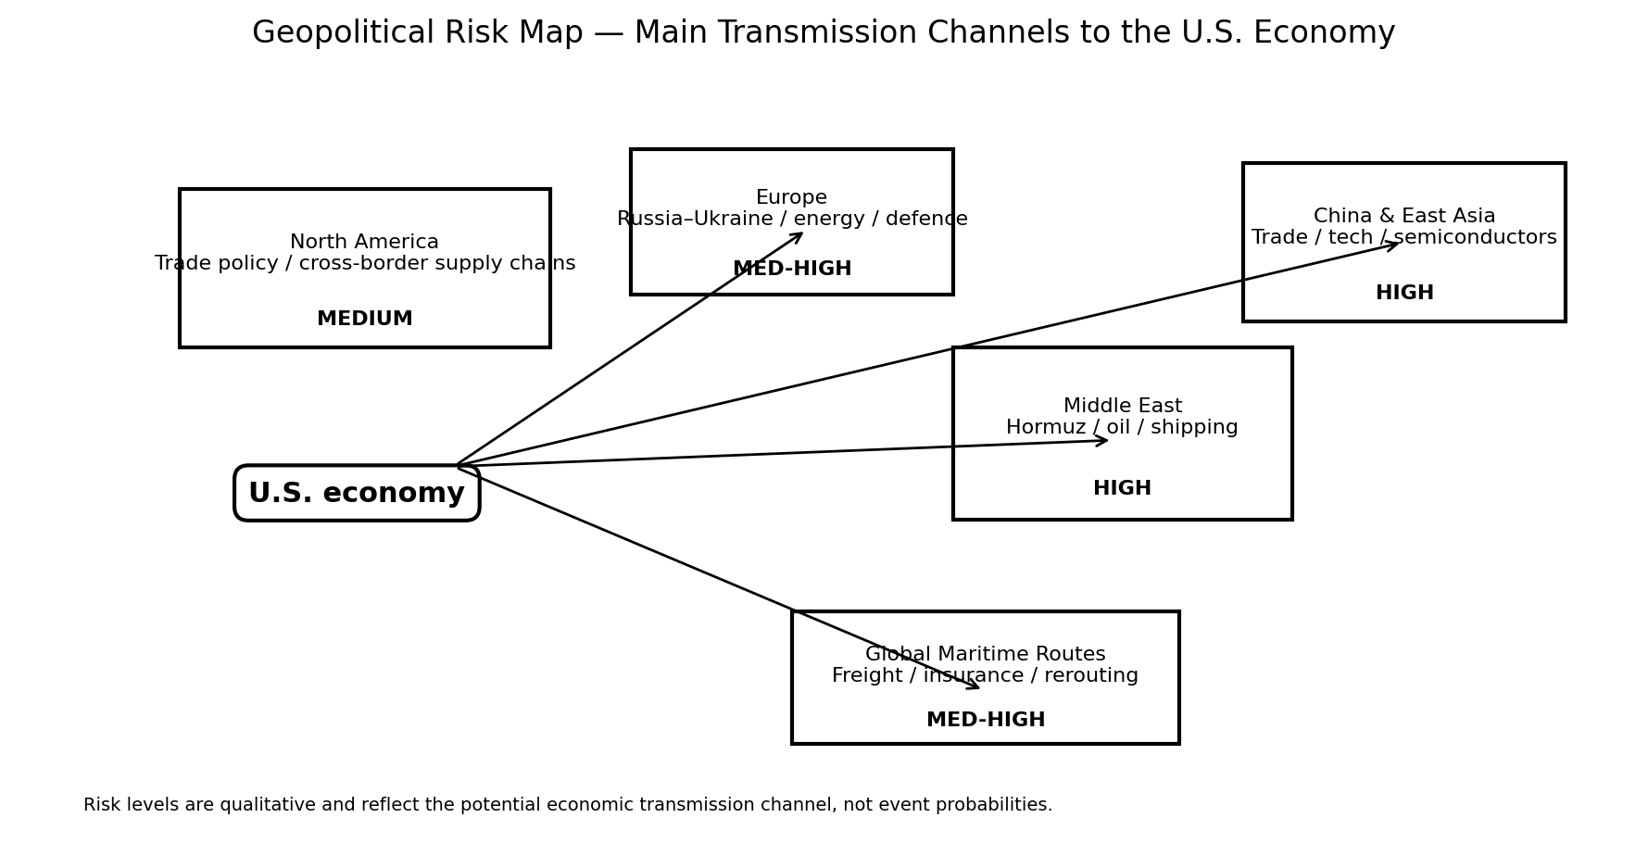
The highest near-term risks are concentrated around the Middle East energy and shipping channel and the U.S.–China trade and technology relationship. European security risks remain important because they influence defence spending, energy markets and confidence. The common feature across all regions is that geopolitical shocks reach the U.S. through prices, supply chains, trade and financial conditions rather than through one single channel.

Geopolitical Risk Matrix
Risk Area | Current Risk | U.S. Transmission | Most Exposed | What to Watch
Middle East / Strait of Hormuz | High | Oil, gas, freight, insurance and inflation | Energy, airlines, transport, chemicals, consumers | Shipping normalization, oil supply and energy prices
U.S.–China trade & technology | High | Tariffs, semiconductors, critical inputs and business confidence | Technology, manufacturing, agriculture, retail | Tariff framework, export controls and bilateral trade mechanism
Russia–Ukraine / Europe | Medium-High | Energy, defence spending, commodities and European demand | Industrials, defence, energy, global exporters | Conflict path, sanctions and European growth
Global maritime routes | Medium-High | Freight costs, delivery times and inventory requirements | Retail, manufacturing, logistics | Hormuz access, rerouting and insurance costs
Technology / semiconductor concentration | Medium | Supply disruption and strategic dependence | AI, cloud, autos, electronics | Advanced-chip capacity and export restrictions

Overall Inference
The U.S. is relatively well placed to absorb many external shocks because of its large domestic market, energy production, deep capital markets and strong technology base. However, this resilience does not remove the risk. A prolonged energy shock, a sharper U.S.–China trade split or a major disruption to global shipping could still raise inflation, tighten financial conditions and weaken business confidence at the same time.

Source Notes
- IMF, World Economic Outlook Update, July 2026.
- IMF / IEA / World Bank / WTO joint statement on the economic impact of the Middle East war, July 2026.
- U.S. Trade Representative, U.S.–China Board of Trade consultation, June 2026.
- Federal Reserve, ECB, Bank of Japan, Bank of England and Reserve Bank of Australia monetary-policy releases.
- U.S. Bureau of Economic Analysis, International Transactions, International Investment Position and Direct Investment releases.

11. U.S. GROWTH CYCLE
Real GDP History | 2015–2025
The U.S. growth cycle over the last decade can be divided into three clear phases: steady pre-pandemic expansion, the sharp 2020 disruption, and a strong recovery followed by normalization. By 2025, real output had moved well above its pre-pandemic level, but the pace of expansion had become more moderate than during the rebound.
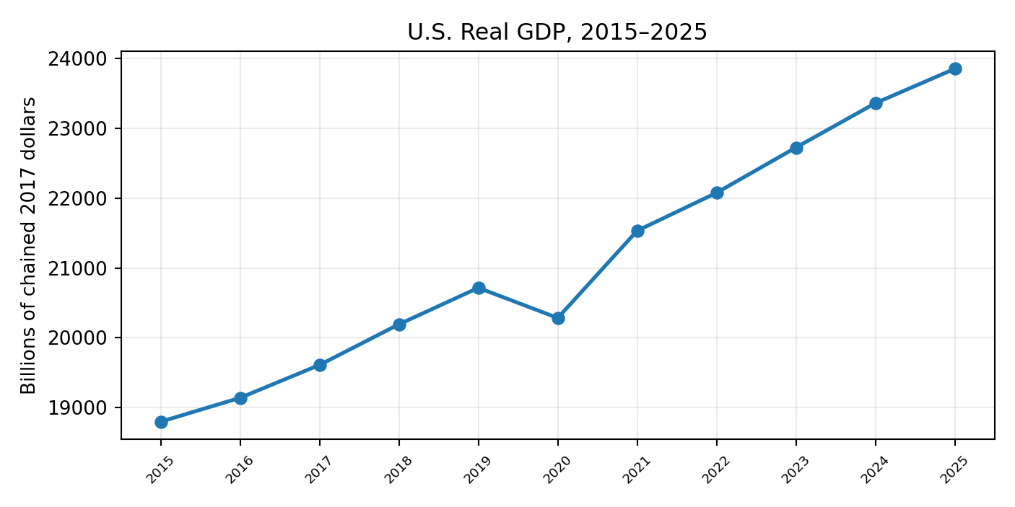
The long-run line remains upward despite the 2020 break. The important change is not a loss of output, but a shift from recovery-driven growth toward a more mature expansion. This makes productivity, investment and underlying domestic demand more important for the next stage of the cycle.
Source: BEA real GDP annual series (GDPCA), via FRED. 2025 real GDP: $23.850 trillion in chained 2017 dollars.

12. QUARTERLY GROWTH MOMENTUM
Q/Q Annualized Real GDP
Quarterly momentum strengthened through the middle of 2025, slowed sharply late in the year, improved in early 2026 and then moderated again in the second quarter. BEA's current second estimate puts Q1 2026 growth at 2.1% annualized and Q2 at 1.5%.
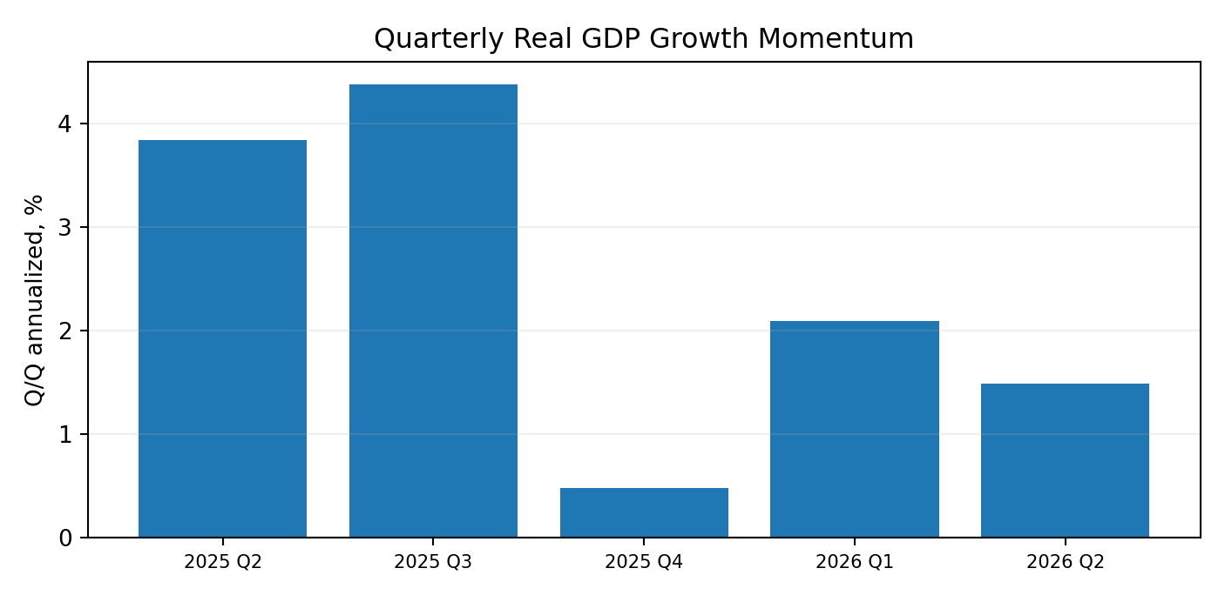
The quarterly pattern is uneven rather than recessionary. Growth has remained positive in early 2026, but the loss of momentum in the second quarter shows that the expansion is no longer moving at the stronger pace seen during parts of 2025. The underlying private-demand picture was firmer than headline GDP, with real final sales to private domestic purchasers rising strongly in Q2.
Source: BEA GDP Second Estimate, Q2 2026; quarterly real GDP levels from BEA/FRED GDPC1. Q/Q annualized rates are calculated from successive quarterly real-GDP levels.

13. GDP BY EXPENDITURE
Consumption, Investment, Government and Trade | Q2 2026
The Q2 2026 expansion was supported by consumer spending, exports and investment. Government spending moved lower, while imports increased and therefore reduced measured GDP. The mix matters because it shows that private demand remained active even as the headline growth rate slowed.
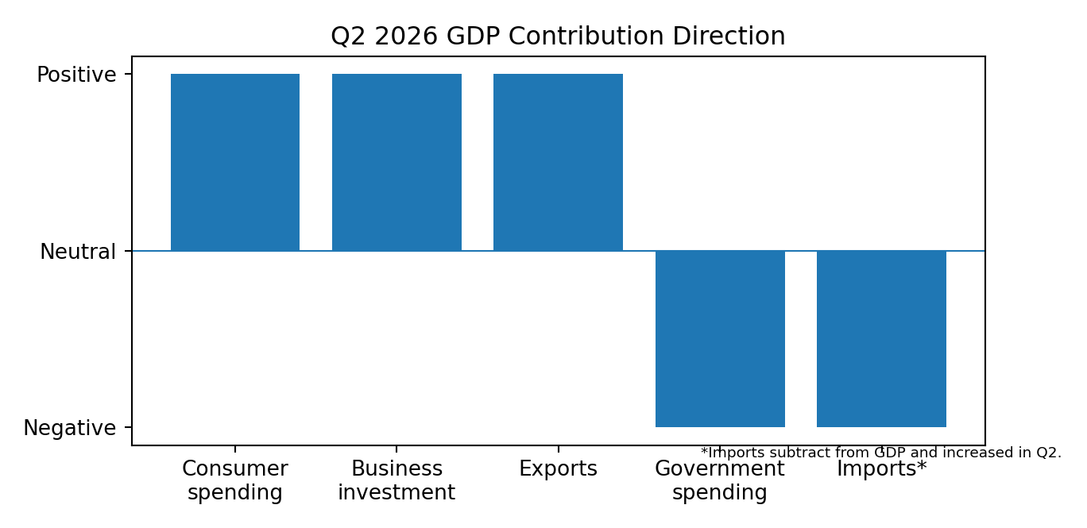
The contribution pattern is more constructive than the headline GDP number alone suggests. Consumer spending and investment continued to add to activity, while part of the weakness came from government spending and the accounting drag from stronger imports. This points to slower aggregate growth without a broad collapse in private demand.
Source: BEA GDP Second Estimate, Q2 2026. The chart shows contribution direction only; it does not invent percentage-point contributions.

14. PERSONAL CONSUMPTION CONTRIBUTION
Consumer Contribution to Growth | Q2 2026
Consumer spending remained a positive contributor to Q2 growth, with increases in both goods and services. BEA's revision also raised the estimate for services spending, led by health care, while some goods categories were revised lower.
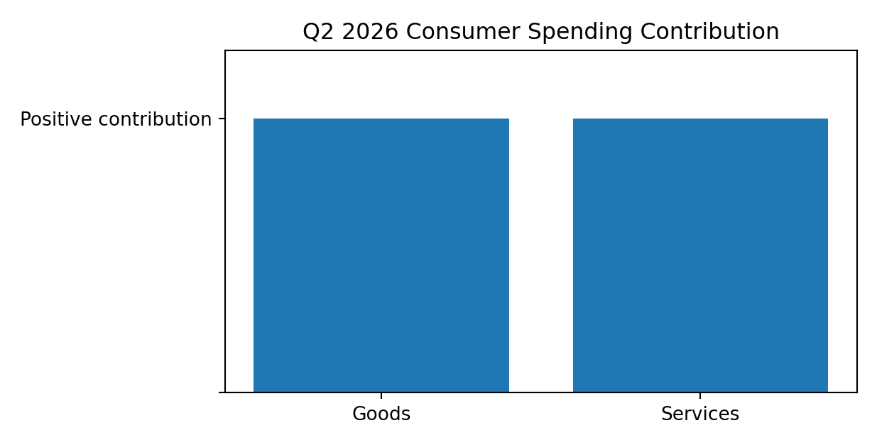
The consumer contribution remains broad enough to support the expansion, rather than depending on a single category. Services continue to provide stability, while goods spending is more sensitive to prices, financing conditions and household confidence. This supports the view that consumption is slowing selectively rather than breaking down.
Source: BEA GDP Second Estimate and technical notes, Q2 2026.

15. BUSINESS INVESTMENT CONTRIBUTION
Non-Residential Investment | Q2 2026
Investment continued to contribute to growth, but the composition was uneven. Equipment and intellectual-property products increased, while private inventories and nonresidential structures moved lower. Within equipment, BEA identified broad gains led by industrial, transportation and information-processing equipment.
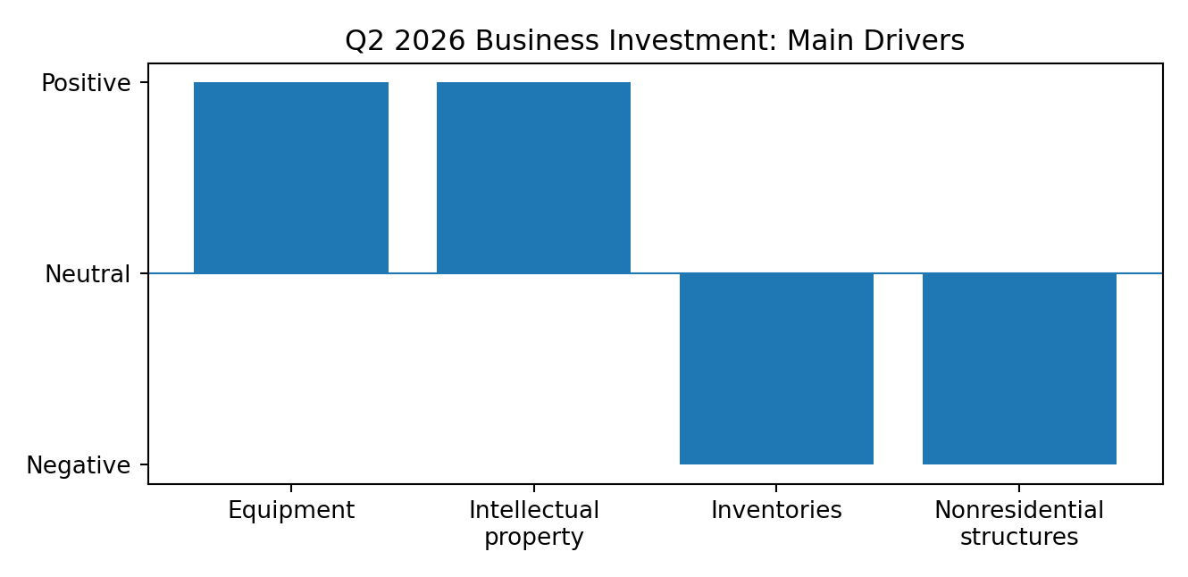
Business investment is becoming more selective. Spending on equipment, software and research remains supportive, which fits the broader technology and productivity investment story. At the same time, weaker structures and inventories show that firms are not expanding capacity uniformly across the economy.
Source: BEA GDP Q2 2026 technical notes. Directional chart reflects BEA-reported increases/decreases, not fabricated contribution percentages.

16. POTENTIAL VS ACTUAL GROWTH
Actual Real GDP, CBO Potential GDP and the Output Gap
Potential GDP represents the level of output the economy can sustain when labor and capital are used at normal rates. Comparing actual GDP with CBO's potential estimate helps show whether demand is running below or above the economy's estimated capacity.
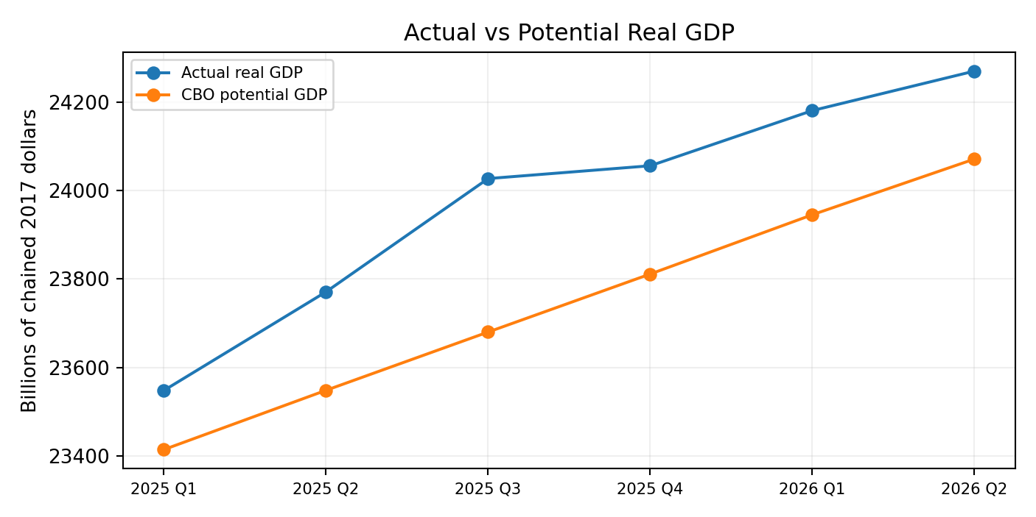
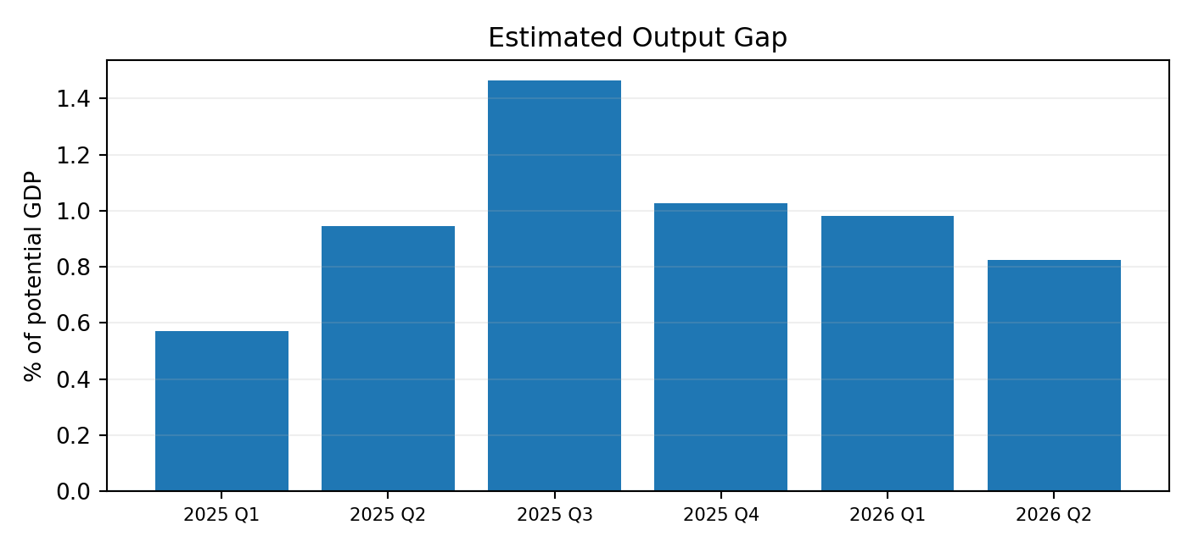
Actual output moved from slightly above potential in early 2025 to a wider positive gap later in the year, before the gap narrowed again in the first half of 2026. Q2 2026 actual real GDP remained above the CBO potential estimate, but by less than in late 2025. This suggests demand is still relatively firm, while the degree of excess pressure has eased.
Source: Actual GDP: BEA/FRED GDPC1. Potential GDP: Congressional Budget Office/FRED GDPPOT, February 2026 vintage. Output gap calculated as (Actual real GDP − Potential real GDP) / Potential real GDP × 100.

Calculation Note
Using the current series, the estimated output gap is approximately 0.98% in Q1 2026 and 0.83% in Q2 2026. Because potential GDP is an estimate rather than an observed statistic, the output gap can change when CBO revises its underlying assumptions.

CHAPTER 07 / CONSUMER ECONOMY

17. The American Consumer
Consumption Engine | Income, Spending, Savings and Credit
The American consumer is still carrying a large share of the expansion, but the support is becoming less comfortable than it was earlier in the cycle. Income is still rising and employment continues to underpin spending, yet households are saving relatively little and are relying on a larger stock of credit. That combination does not point to a consumer collapse; it points to a consumer that is becoming more selective.
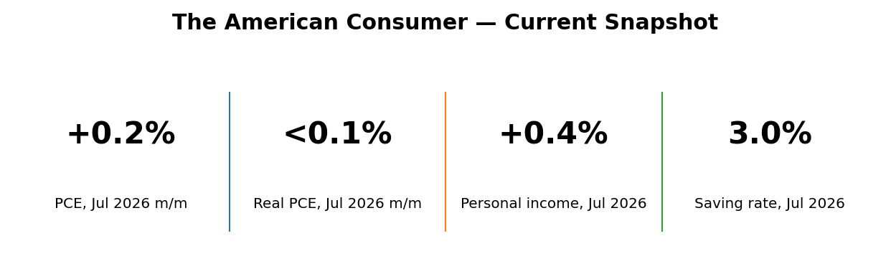
Indicator | Latest reading | Period | What it says
Personal consumption expenditures | +0.2% m/m | Jul 2026 | Spending still increased
Real PCE | Less than +0.1% m/m | Jul 2026 | Volume growth was almost flat
Personal income | +0.4% m/m | Jul 2026 | Income continued to support demand
Personal saving rate | 3.0% of DPI | Jul 2026 | Financial cushion remains thin
Total household debt | $18.77 trillion | Q2 2026 | Debt stock remains high
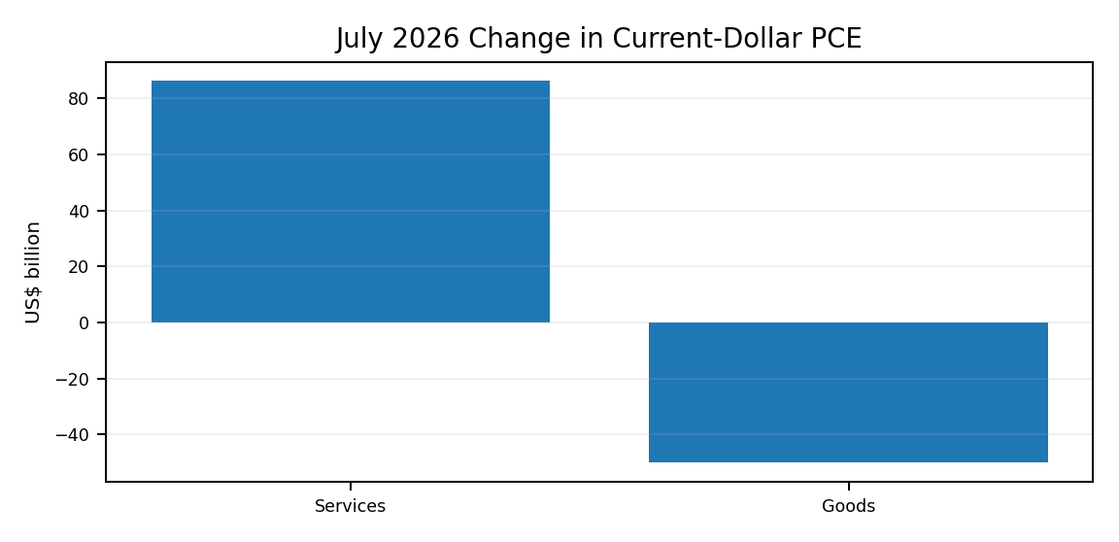
July spending was supported by services, while goods spending moved the other way. That split is important because it shows that the consumer is still active, but the strength is not broad across every category. Services are providing more stability than discretionary goods.
Source: BEA, Personal Income and Outlays, July 2026; Federal Reserve Bank of New York, Household Debt and Credit, Q2 2026.
BrandEssence Economic Intelligence | Chapter 7: Consumer Economy | Page 17

CHAPTER 07 / CONSUMER ECONOMY

18. Consumer Spending
PCE Trends | Nominal and Real Spending
Consumer spending is still growing, but the latest monthly pattern is softer than the headline dollar increase suggests. Nominal PCE rose in July, while real PCE was nearly unchanged after adjusting for prices. This means households spent more dollars, but bought only slightly more in volume terms.
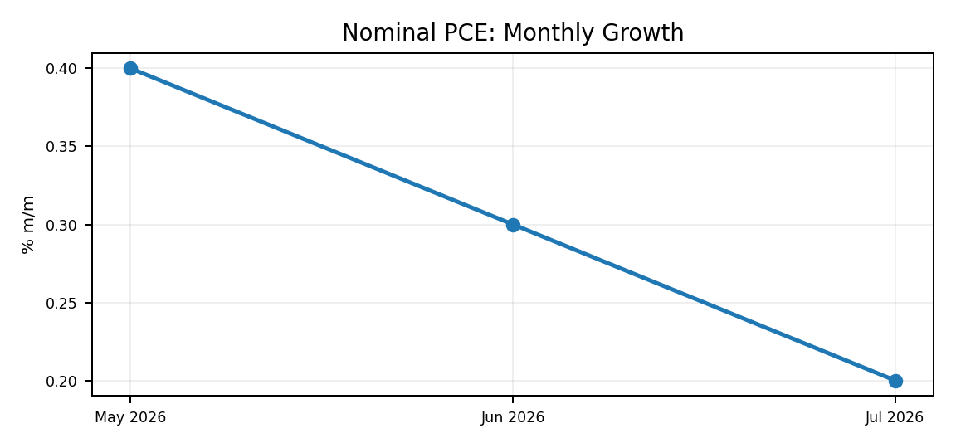 | 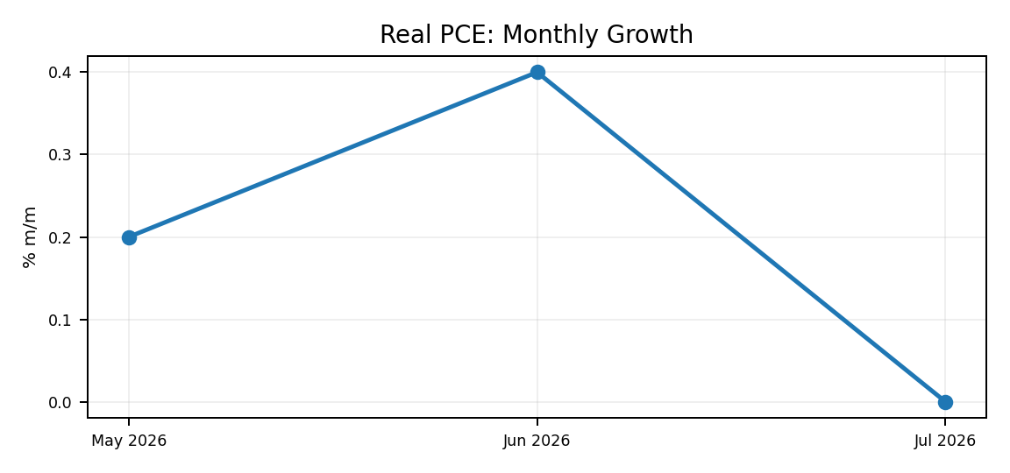
Nominal spending has continued to rise, but real spending lost momentum in July. The gap between the two measures shows why inflation still matters for the consumer: part of the increase in household outlays reflects higher prices rather than stronger consumption volumes.
Measure | May 2026 | June 2026 | July 2026
Current-dollar PCE, m/m | +0.4% | +0.3% | +0.2%
Real PCE, m/m | +0.2% | +0.4% | <+0.1%
July spending mix | — | — | Services +$86.2B; Goods -$49.9B
The current pattern is consistent with a consumer who has not stopped spending but is becoming more deliberate. Services remain a steadier source of demand, while goods are more exposed to financing costs, replacement cycles and price sensitivity.
Source: BEA, Personal Income and Outlays, July 2026. July current-dollar PCE increased $36.3 billion.
BrandEssence Economic Intelligence | Chapter 7: Consumer Economy | Page 18
CHAPTER 08 / BUSINESS INVESTMENT & CORPORATE SECTOR

22. U.S. Investment Cycle
Business Investment | The Shift Toward Equipment and Intellectual Property
Business investment remains an important source of resilience in the U.S. economy, but the cycle is becoming more selective. Spending is strongest in equipment and intellectual property, while structures have been much flatter. That mix points to companies prioritising technology, automation and productive capacity rather than expanding every type of physical footprint.
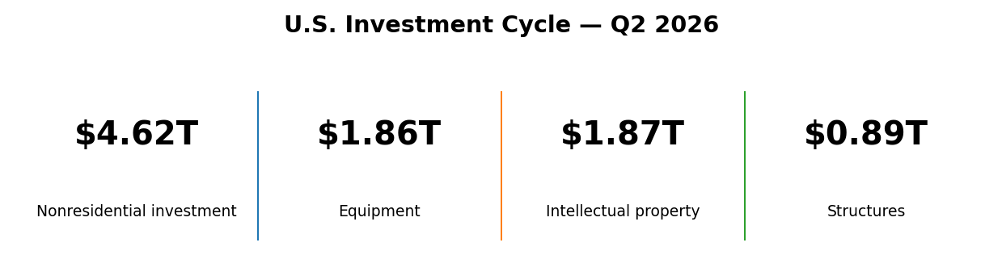
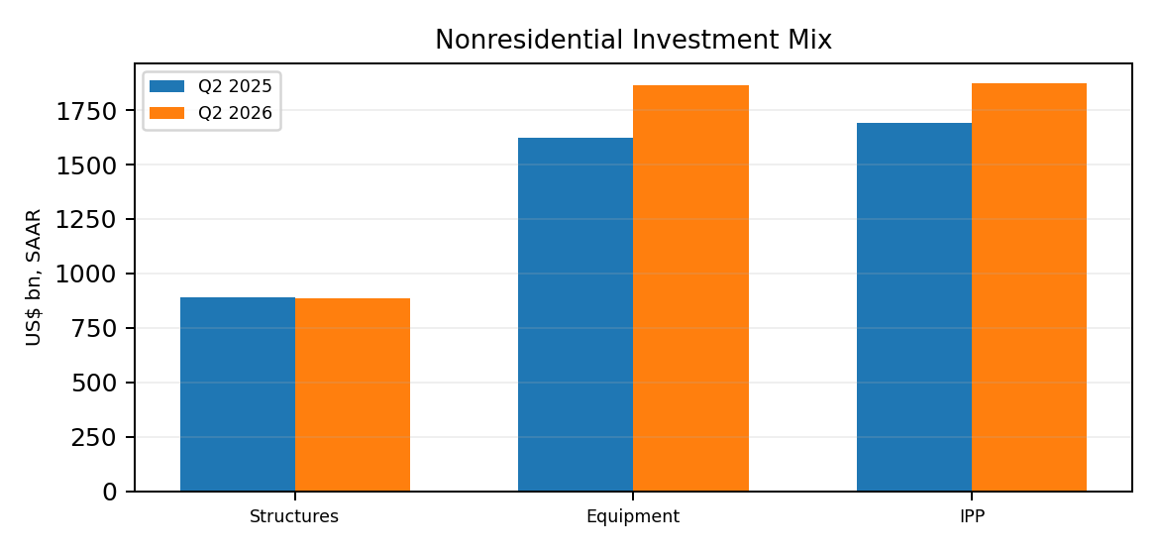 | 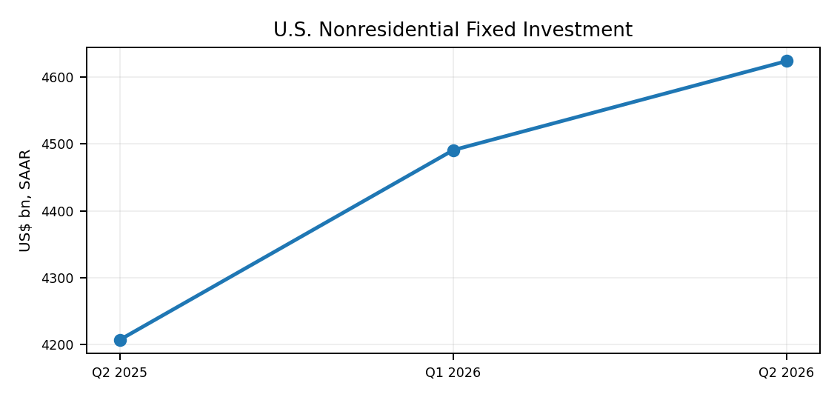
The investment cycle is still moving forward, but the composition has changed. Equipment and intellectual-property spending are doing most of the work, while structures have not kept pace. This is consistent with a corporate sector putting more capital into technology and efficiency than into broad-based physical expansion.
Investment measure | Q2 2025 | Q2 2026 | Change
Nonresidential fixed investment | $4,207.5B | $4,623.4B | +9.9%
Structures | $891.3B | $885.8B | -0.6%
Equipment | $1,625.0B | $1,864.8B | +14.8%
Intellectual property products | $1,691.2B | $1,872.8B | +10.7%
Source: BEA NIPA Table 5.3.5 / FRED, Q2 2026. Values are seasonally adjusted annual rates.
BrandEssence Economic Intelligence | Chapter 8 | Page 22

CHAPTER 08 / BUSINESS INVESTMENT & CORPORATE SECTOR

23. Corporate Capex
Equipment, Software and Structures | Where Companies Are Spending
Corporate capex is increasingly concentrated in assets that raise processing power, automation and knowledge capital. Information-processing equipment, software and research and development all moved higher over the past year, while the structures component remained comparatively subdued.
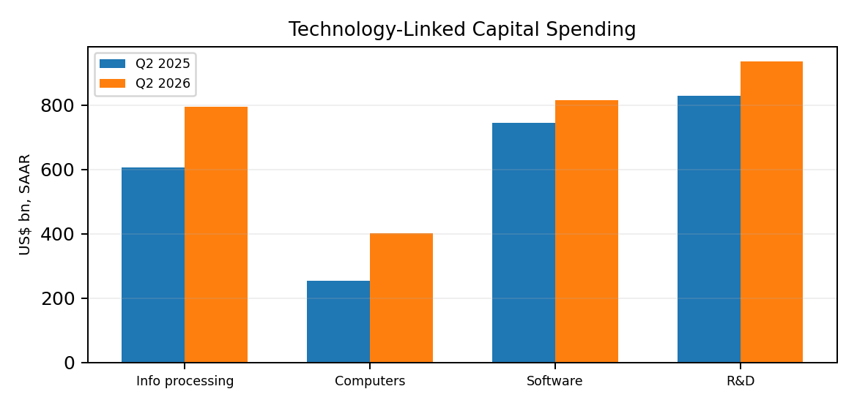 | 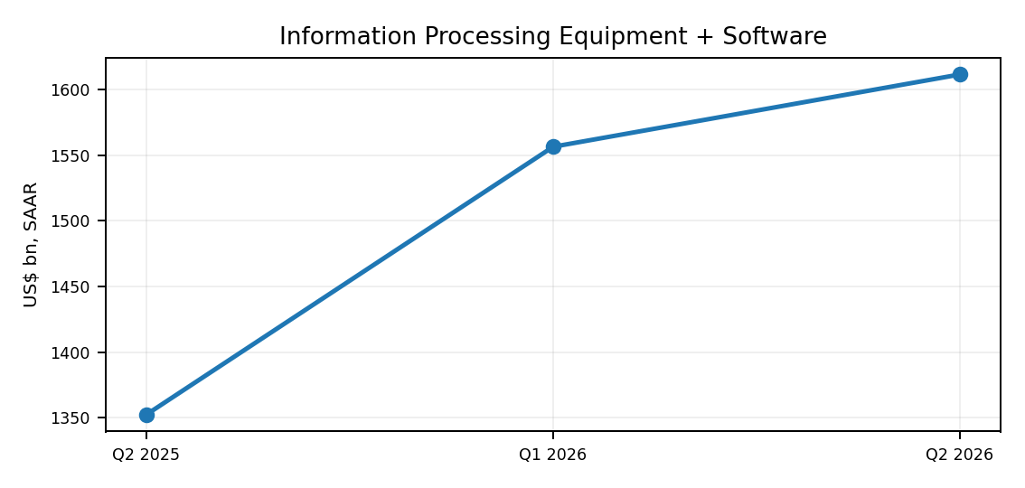
The strongest capex growth is in digital and knowledge-based assets. Information-processing equipment and software have risen much faster than structures, suggesting that firms are investing first in computing capacity and productivity tools. The pattern is supportive for technology-linked suppliers but less broad than a traditional construction-led capex boom.
Capex category | Q2 2025 | Q2 2026 | Y/Y
Information-processing equipment | $606.5B | $794.9B | +31.1%
Computers & peripherals | $253.8B | $400.6B | +57.9%
Software | $745.9B | $816.6B | +9.5%
Research & development | $829.8B | $936.0B | +12.8%
Power & communication structures | $167.6B | $175.4B | +4.6%
Source: BEA private fixed investment by type, Q2 2026. Dollar values are SAAR.
BrandEssence Economic Intelligence | Chapter 8 | Page 23

CHAPTER 08 / BUSINESS INVESTMENT & CORPORATE SECTOR

24. AI Investment Boom
Data Centers, Chips and Software | AI-Enabling Capital Cycle
There is no single official national-accounts series called 'AI investment', so the most defensible way to track the boom is through the assets that make it possible: computers, information-processing equipment, software, R&D and power/communications infrastructure. These measures show a clear acceleration in digital capital spending.
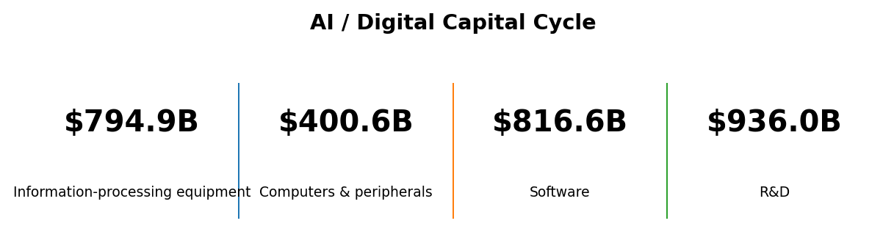
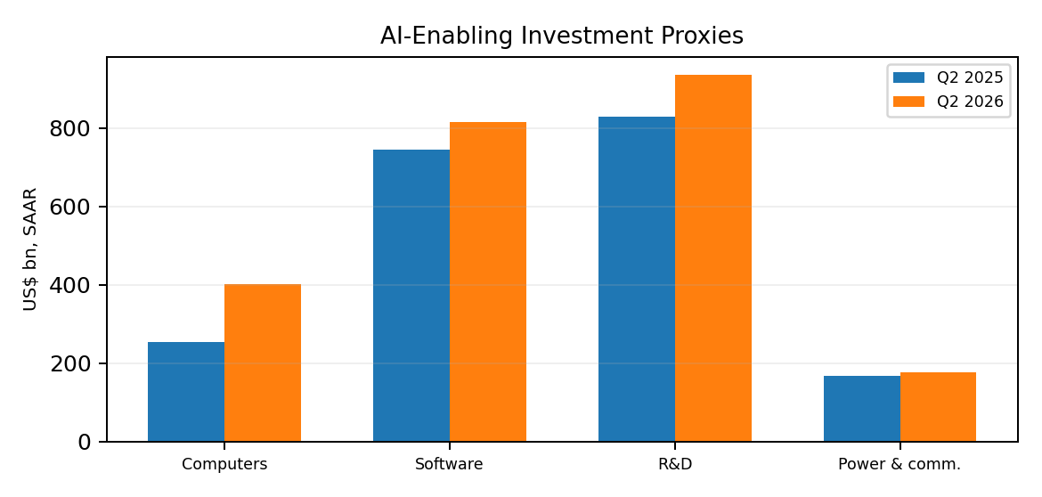
The AI cycle is visible most clearly in computing hardware and information-processing equipment, where spending has risen sharply. Software and R&D are also expanding, while power and communications investment is increasing more gradually. The opportunity is therefore spreading from chips and servers into the wider infrastructure needed to operate them.
The numbers on this page should be read as AI-enabling investment proxies, not as a claim that every dollar in these categories is AI-related. That distinction keeps the report grounded in official data while still capturing the direction of the technology investment cycle.
Source: BEA NIPA fixed-investment data, Q2 2026. AI interpretation is BrandEssence analysis of official investment categories.
BrandEssence Economic Intelligence | Chapter 8 | Page 24

CHAPTER 08 / BUSINESS INVESTMENT & CORPORATE SECTOR

25. Corporate Profits & Cash Flow
Profits and Investment Capacity | Corporate Financial Headroom
Corporate profitability strengthened sharply in the second quarter, improving the internal capacity of firms to fund investment. Profits from current production reached an annualised $4.83 trillion, while after-tax profits also moved higher. Stronger profits do not guarantee higher capex, but they reduce the dependence of well-positioned firms on external finance.
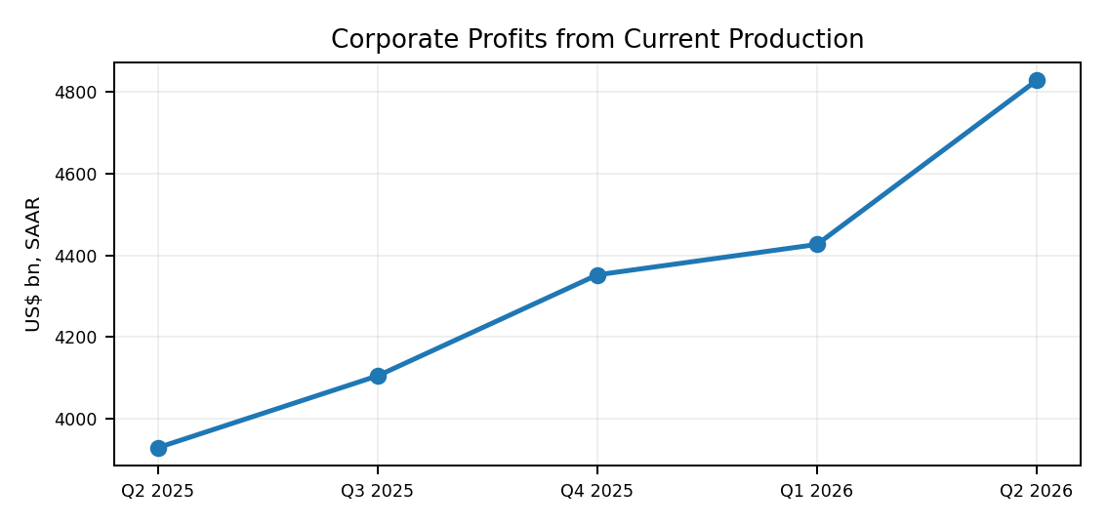 | 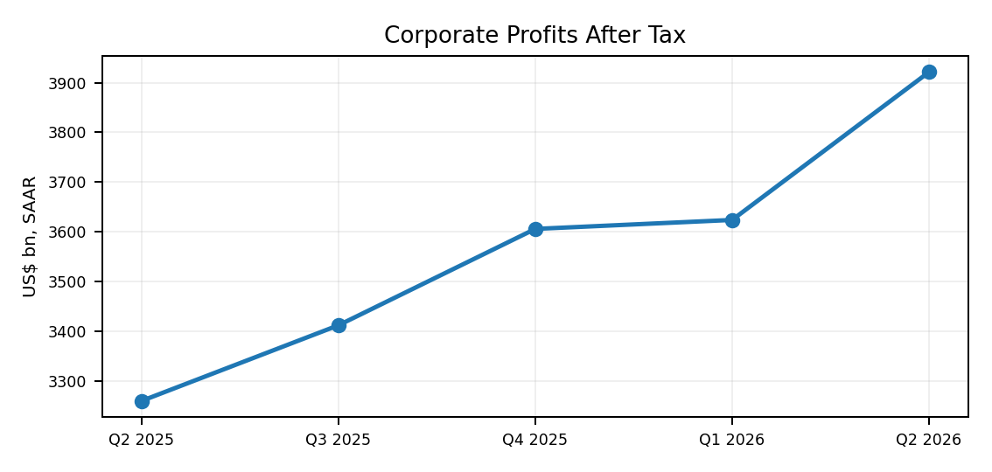
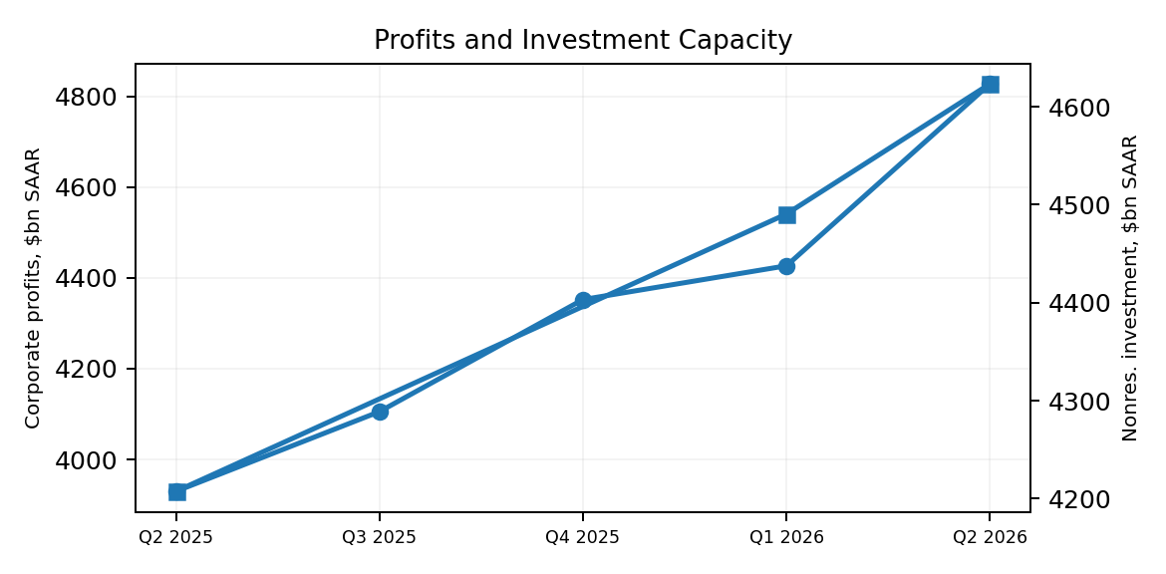
Profits and nonresidential investment are both higher than a year ago, giving the corporate sector more room to keep investing despite elevated borrowing costs. The important point is the combination: stronger earnings can cushion the impact of restrictive financing, particularly for large firms with substantial internal cash generation.
Profit measure | Q2 2025 | Q1 2026 | Q2 2026
Profits from current production | $3,929.7B | $4,426.5B | $4,827.4B
Domestic industry profits | $3,458.2B | $3,864.4B | $4,245.6B
Nonfinancial domestic profits | $2,680.8B | $2,971.1B | $3,280.7B
Profits after tax | $3,259.4B | $3,623.7B | $3,921.4B
Source: BEA corporate profits, Q2 2026 second estimate; BEA/FRED quarterly profit series. Values are SAAR.
BrandEssence Economic Intelligence | Chapter 8 | Page 25

CHAPTER 08 / BUSINESS INVESTMENT & CORPORATE SECTOR

26. Investment Financing Conditions
Rates, Spreads and Lending | How Financing Reaches Capex
Financing conditions are still restrictive compared with the easy-money environment of the late 2010s, but they are not uniformly tightening. The Federal Reserve's July 2026 lending survey found C&I standards broadly unchanged, stronger demand from large and middle-market firms, and narrower loan-rate spreads at many banks. Corporate bond spreads also remained low by historical standards earlier in 2026.
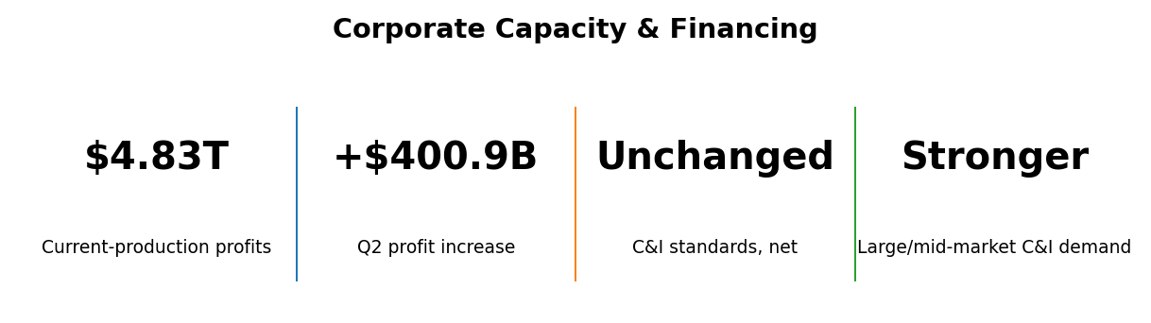
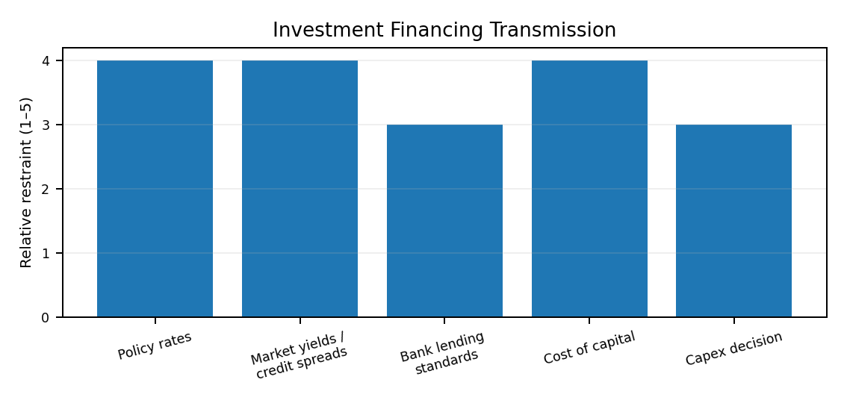
The financing channel is restrictive mainly because the overall cost of capital remains high, not because credit has disappeared. Large firms still have access to bank and market funding, and lending terms have stopped tightening across much of the C&I market. This creates a two-speed investment environment: profitable, investment-grade firms can continue to fund capex, while smaller or more leveraged borrowers remain more sensitive to rates.
Financing channel | Latest evidence | Investment implication
C&I lending standards | Basically unchanged in Q2 2026 | No broad new tightening for business loans
Large/mid-market C&I demand | Stronger on net | Firms are still seeking credit
Loan-rate spreads | Narrower at many banks | Some easing in loan pricing
Corporate bond spreads | Low end of historical range in spring 2026 | Market access remains comparatively supportive
CRE standards | Easier/unchanged in parts of the market | Conditions differ by property type
Source: Federal Reserve, July 2026 Senior Loan Officer Opinion Survey; Federal Reserve Financial Stability Report, May 2026.
BrandEssence Economic Intelligence | Chapter 8 | Page 26

CHAPTER 07 / CONSUMER ECONOMY

19. Household Income & Wages
Income Growth | Earnings and Purchasing Capacity
Household income remains one of the strongest supports behind consumption. Personal income accelerated in July and disposable income rose faster than total income. Wage growth has also remained positive, although it is no longer running at the unusually rapid pace seen earlier in the post-pandemic period.
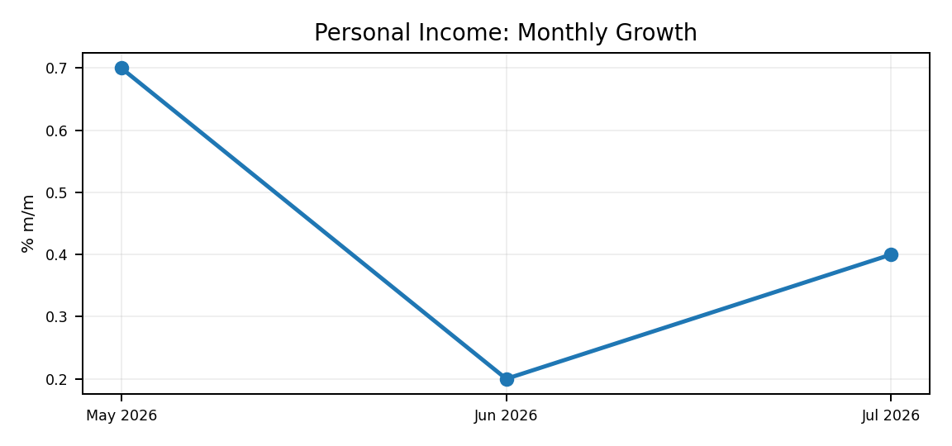 | 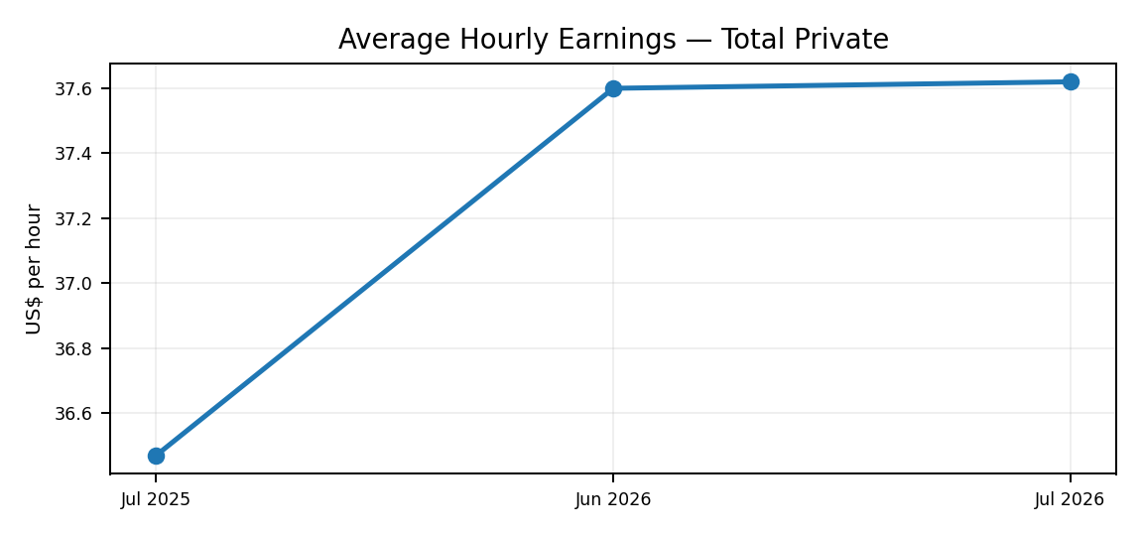
Income growth improved in July while hourly earnings remained firm. This gives households an ongoing base for spending, but wage gains are now closer to a normal expansion pace. That is healthier for inflation, although it also means consumption is less likely to receive the same wage-driven boost seen earlier in the recovery.
Income / wage measure | Latest | Period
Personal income | +0.4% m/m | Jul 2026
Disposable personal income | +0.5% m/m | Jul 2026
Real disposable personal income | +0.4% m/m | Jul 2026
Average hourly earnings — total private | $37.62/hour | Jul 2026
Average hourly earnings growth | +3.2% y/y | Jul 2026
Average private workweek | 34.3 hours | Jul 2026
Source: BEA, Personal Income and Outlays, July 2026; BLS, Employment Situation, July 2026.
BrandEssence Economic Intelligence | Chapter 7: Consumer Economy | Page 19

CHAPTER 07 / CONSUMER ECONOMY

20. Savings & Household Balance Sheets
Savings, Debt and Household Financial Cushion
Household balance sheets are not uniformly weak, but the margin for error has narrowed. The personal saving rate remains low by historical standards, while total household debt is close to $18.8 trillion. Most of that debt is mortgage-related, which makes the overall balance sheet different from one dominated by short-term consumer borrowing.
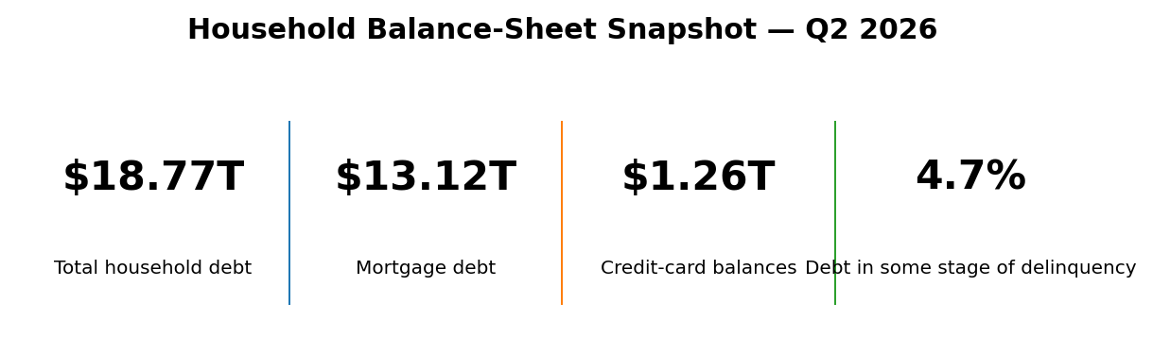
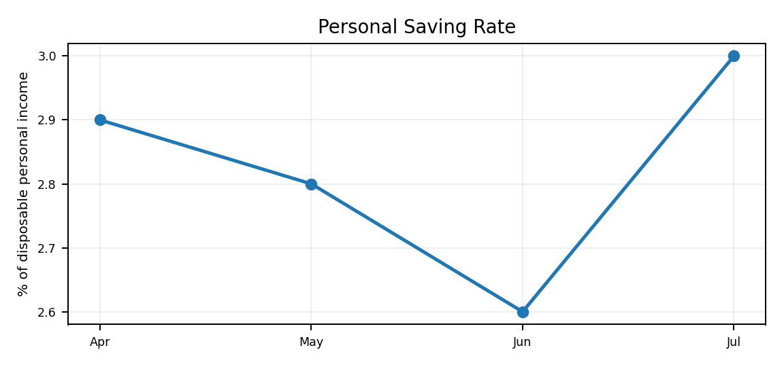 | 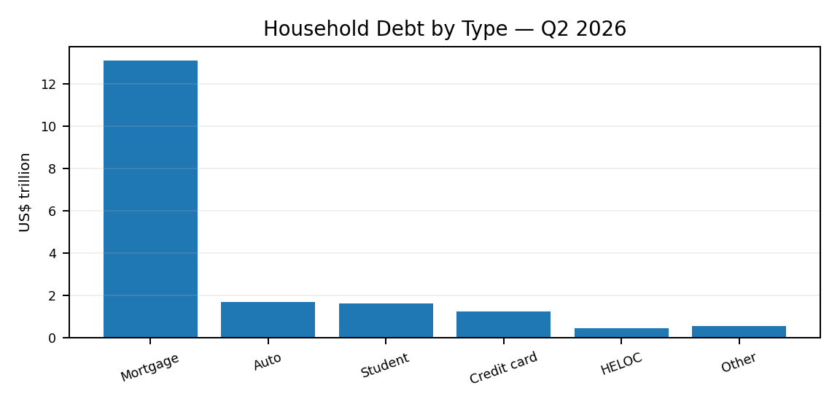
The saving rate recovered in July but remains low, so households have a smaller cash-flow buffer if income weakens or prices rise again. At the same time, the debt mix is heavily concentrated in mortgages rather than revolving credit. The balance sheet therefore looks stretched in places, but not uniformly fragile.
Debt category | Q2 2026 balance | Quarterly change
Mortgage | $13.117T | -$74B*
Auto | $1.713T | +$28B
Student | $1.651T | -$7B
Credit card | $1.263T | +$21B
HELOC | $0.459T | +$13B
Other | $0.568T | +$6B
*The New York Fed notes that the Q2 mortgage decline partly reflected a temporary reporting gap related to a servicing transfer.
Source: BEA personal saving rate; Federal Reserve Bank of New York, Household Debt and Credit, Q2 2026.
BrandEssence Economic Intelligence | Chapter 7: Consumer Economy | Page 20

CHAPTER 07 / CONSUMER ECONOMY

21. Consumer Credit & Delinquencies
Credit Stress | Where Household Pressure Is Appearing
Consumer credit is still expanding in the areas most closely linked to day-to-day household financing. Credit-card and auto balances both increased in the second quarter. The broader delinquency picture improved slightly, but new delinquencies in auto and credit-card borrowing remain elevated enough to deserve attention.
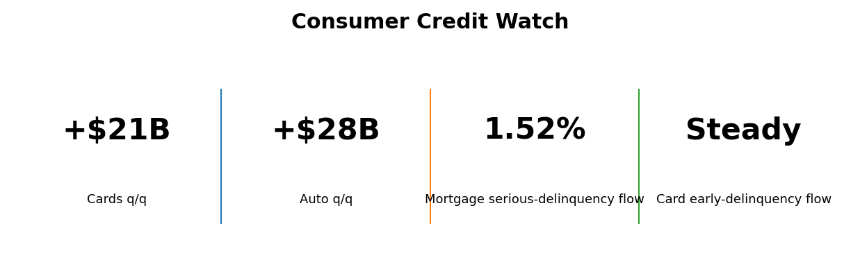
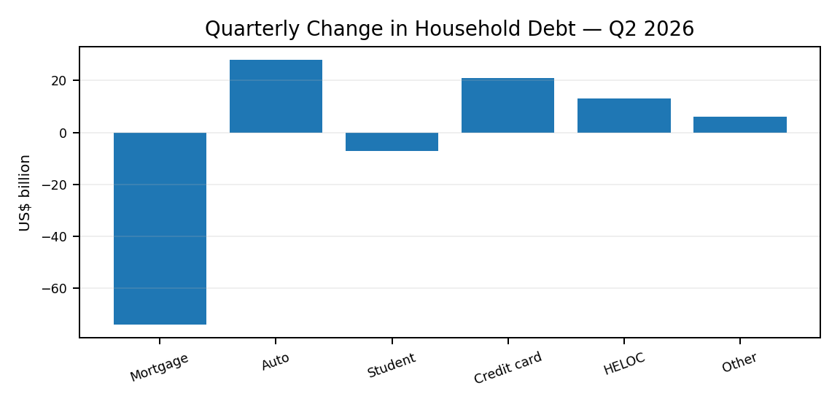
The latest credit data show pressure rather than a system-wide breakdown. Card and auto balances are still rising, while aggregate delinquency edged lower. The risk is concentrated among borrowers with less financial flexibility, which means consumer stress can increase even while the overall household sector continues to spend.
Credit indicator | Q2 2026 | Interpretation
Debt in some stage of delinquency | 4.7% | Slight improvement from Q1
Mortgage flow into serious delinquency | 1.52% | Up from 1.29% a year earlier
Credit-card balances | $1.263T | +$21B q/q
Auto-loan balances | $1.713T | +$28B q/q
Credit-card early-delinquency transition | Largely steady | Still elevated in the broader recent context
Auto early-delinquency transition | Ticked up slightly | Area to monitor
For the 2027 outlook, the consumer-credit channel matters because higher delinquencies can tighten lending standards before they materially weaken aggregate spending. The most useful signal is therefore not the debt total alone, but whether stress continues to spread across cards, autos and mortgages.
Source: Federal Reserve Bank of New York, Quarterly Report on Household Debt and Credit, Q2 2026, released August 11, 2026.
BrandEssence Economic Intelligence | Chapter 7: Consumer Economy | Page 21
CHAPTER 09 / INDUSTRIAL & MANUFACTURING ECONOMY

27. Industrial Production
Total Industrial Production | Current Manufacturing Cycle
Industrial activity has been broadly flat through the middle of 2026. Output has not fallen sharply, but it has also struggled to build sustained momentum. That makes the current industrial cycle look more like a period of consolidation than a broad manufacturing downturn.
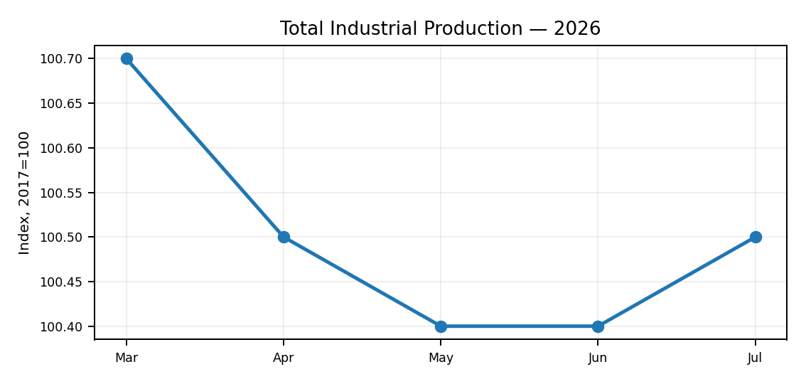
Industrial production has moved within a narrow range in recent months. The lack of a strong upward move suggests demand is still uneven, while the absence of a sharp decline points to underlying resilience. For the broader economy, industry is currently a stabilising rather than a leading growth engine.
Indicator | Latest | Period | Reading
Total industrial production | 100.5 | Jul 2026 | 2017=100
Monthly change | +0.1% | Jul 2026 | Modest increase
Year-over-year change | Positive | Jul 2026 | Output above year-earlier level
Mining | Mixed | Jul 2026 | Commodity-sensitive
Utilities | Volatile | Jul 2026 | Weather-sensitive
Source: Federal Reserve, Industrial Production and Capacity Utilization (G.17), August 2026 release.
BrandEssence Economic Intelligence | Chapter 9 | Page 27

CHAPTER 09 / INDUSTRIAL & MANUFACTURING ECONOMY

28. Manufacturing Outlook
Manufacturing Activity | Output, Demand and Investment
Manufacturing remains mixed rather than uniformly weak. Traditional factory activity is still sensitive to rates and global demand, while technology, defence, energy and supply-chain investment are supporting selected industries. The result is a two-speed manufacturing environment.
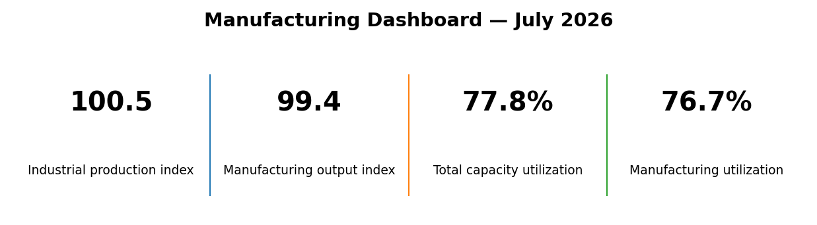
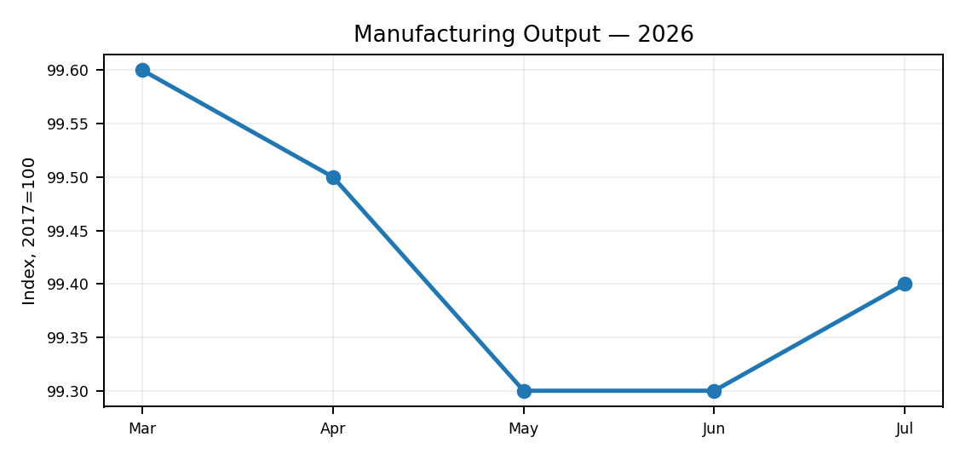
Manufacturing output has been relatively flat, which confirms that the sector is not yet in a broad acceleration. The more constructive part of the outlook comes from investment-led industries rather than from a general rise in factory demand. That distinction matters when assessing sector opportunities.
Manufacturing signal | Current reading | Interpretation
Manufacturing output index | 99.4 | Broad activity remains subdued
Capacity utilization | 76.7% | Below full-pressure conditions
Technology-linked capex | Strong | Supports machinery/electronics demand
Durable-goods orders | Volatile | Aircraft can distort headline
Core capital-goods orders | Positive in July | Better signal for business equipment demand
Source: Federal Reserve G.17; U.S. Census Bureau Manufacturers' Shipments, Inventories and Orders, July 2026.
BrandEssence Economic Intelligence | Chapter 9 | Page 28

CHAPTER 09 / INDUSTRIAL & MANUFACTURING ECONOMY

29. Capacity Utilisation
Industrial Capacity | How Much Slack Remains
Capacity utilisation remains below the levels normally associated with an overheated industrial sector. That gives manufacturers some room to increase output without immediately requiring a large new wave of physical capacity, although conditions differ significantly by industry.
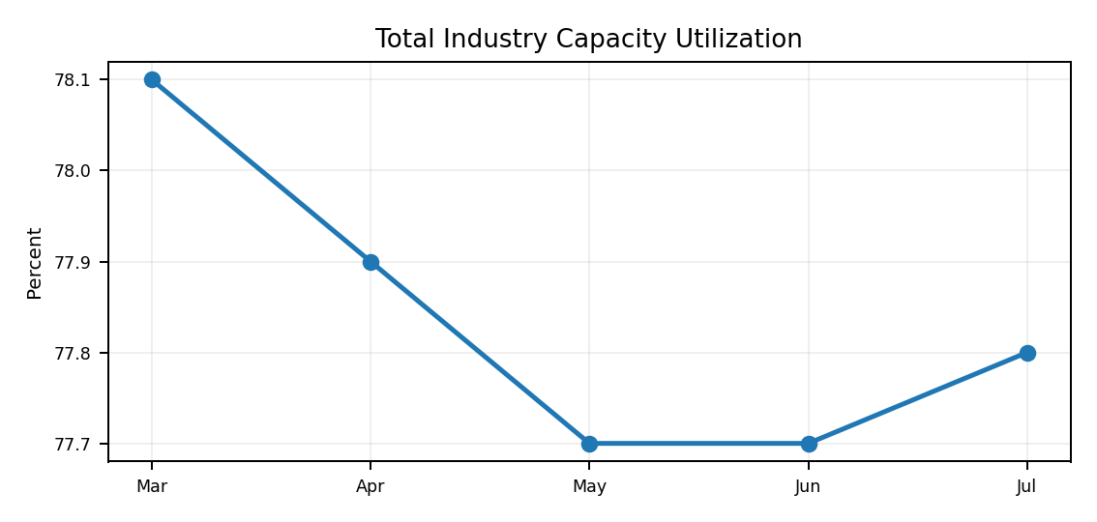 | 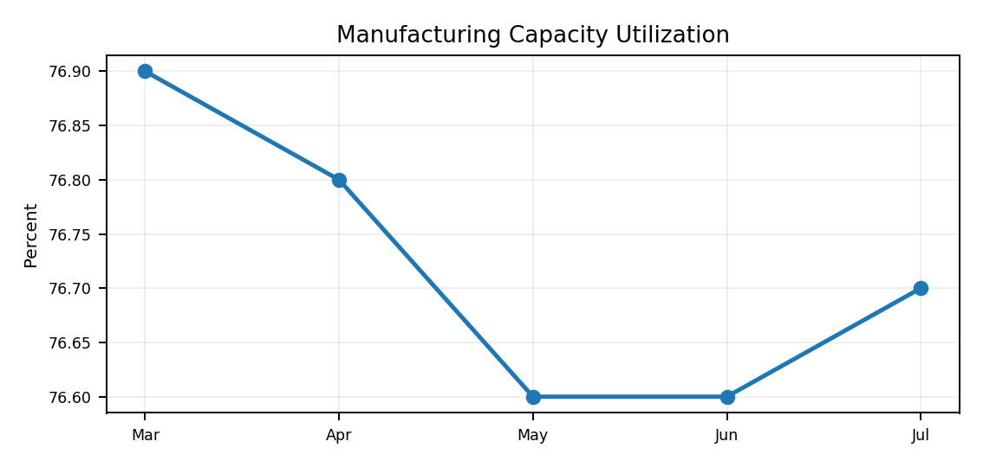
Utilisation has been broadly stable and remains below 80% for total industry, with manufacturing lower still. This suggests the sector has spare capacity and limited near-term overheating pressure. It also explains why new investment is being directed selectively toward strategic bottlenecks rather than across the entire industrial base.
Measure | Jul 2026 | What it means
Total industry utilization | 77.8% | Moderate spare capacity
Manufacturing utilization | 76.7% | No broad capacity squeeze
Investment implication | Selective | New capacity most likely where demand is structural
Inflation implication | Contained | Limited evidence of economy-wide industrial bottlenecks
Source: Federal Reserve, Industrial Production and Capacity Utilization, July 2026.
BrandEssence Economic Intelligence | Chapter 9 | Page 29

CHAPTER 09 / INDUSTRIAL & MANUFACTURING ECONOMY

30. Orders & Capital Goods
Durable Goods and Core Capital Goods | Forward Demand Signal
Headline durable-goods orders can move sharply from month to month because large aircraft orders distort the total. Core capital goods are therefore a better guide to underlying business-equipment demand. July's data showed a weaker headline but a firmer core signal.
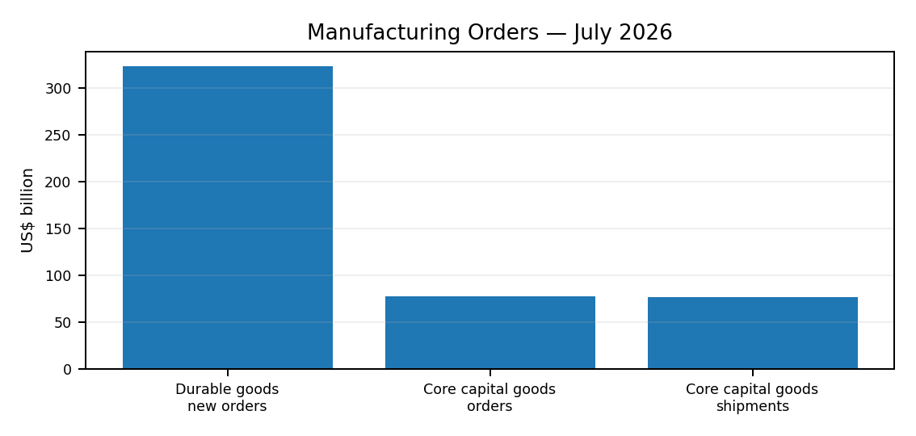 | 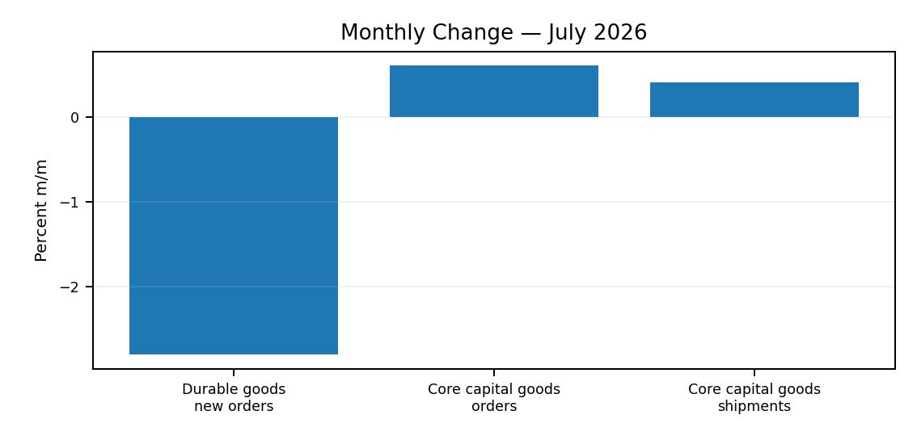
The headline decline in durable-goods orders looks weaker than the underlying investment signal because transport equipment is highly volatile. Core capital-goods orders increased, suggesting firms are still committing to equipment spending. This fits the broader picture of selective capex resilience.
Orders measure | Jul 2026 | Monthly change
Durable-goods new orders | ~$322.6B | -2.8%
Core capital-goods orders | ~$77.4B | +0.6%
Core capital-goods shipments | ~$76.8B | +0.4%
Interpretation | Core firmer than headline | Aircraft/transport volatility matters
Source: U.S. Census Bureau, Advance Report on Durable Goods / M3, July 2026. Rounded values shown.
BrandEssence Economic Intelligence | Chapter 9 | Page 30

CHAPTER 09 / INDUSTRIAL & MANUFACTURING ECONOMY

31. Reshoring & Industrial Policy
Domestic Manufacturing | Supply-Chain and Capacity Strategy
U.S. industrial policy is changing the geography and composition of investment. Semiconductor incentives, infrastructure spending, energy investment and supply-chain diversification are encouraging firms to place more strategic capacity inside the United States. This is not a complete reversal of globalisation; it is a shift toward resilience in industries where disruption carries a high economic or security cost.
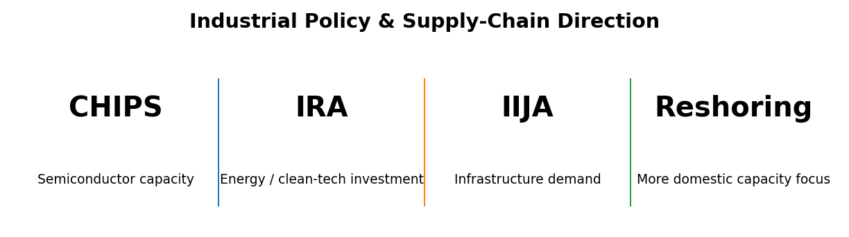
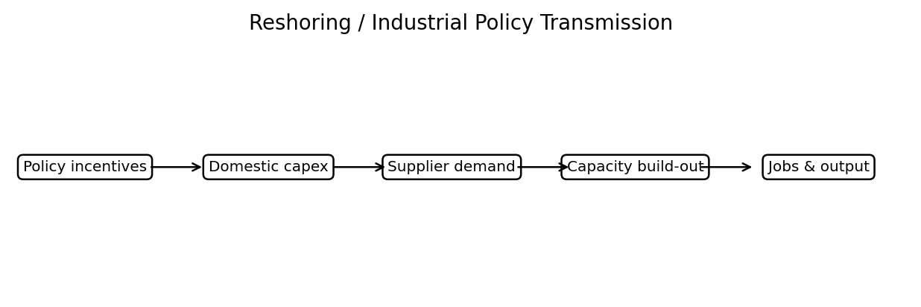
The reshoring story works through investment before it shows up fully in industrial output. Policy incentives and supply-chain concerns first raise domestic capex, which then supports construction, equipment suppliers and local capacity. The economic effect is therefore gradual, but it can become persistent once new plants and supplier networks are operating.
Policy / trend | Main industrial channel | Likely beneficiaries
CHIPS incentives | Semiconductor fabrication and supply chain | Chips, equipment, construction, power
Infrastructure investment | Transport, utilities and public works | Materials, machinery, engineering
Energy investment | Generation, grid and manufacturing | Electrical equipment, storage, industrial suppliers
Supply-chain diversification | More domestic / regional sourcing | Manufacturing, logistics, specialised suppliers
Reshoring | Strategic production closer to U.S. demand | Selected high-value manufacturing clusters
Reshoring should not be measured with one headline number. Announced projects, construction spending, equipment investment, manufacturing employment and actual production all capture different stages of the process. The most useful approach is to follow these indicators together.
Source: U.S. Department of Commerce / CHIPS for America; Infrastructure Investment and Jobs Act implementation; BEA/Census investment and manufacturing indicators. Interpretation is BrandEssence.
BrandEssence Economic Intelligence | Chapter 9 | Page 31

CHAPTER 10 / SERVICES ECONOMY

32. Services Economy
Services Activity | The Main Domestic Growth Engine
Services remain the broadest part of the U.S. economy and continue to provide stability when goods-producing activity is uneven. The latest official industry accounts available before the September 30 update show private services value added still expanding in the first quarter, with information and professional, scientific and technical services among the strongest individual contributors to overall GDP growth.
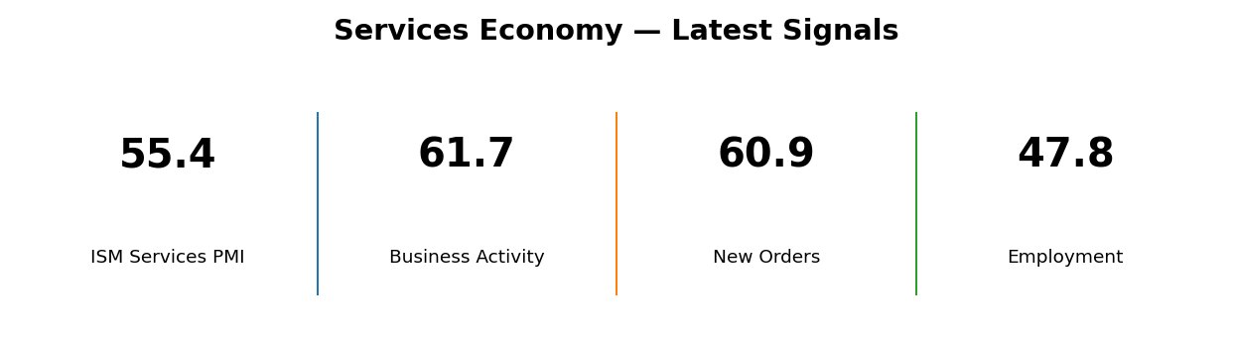
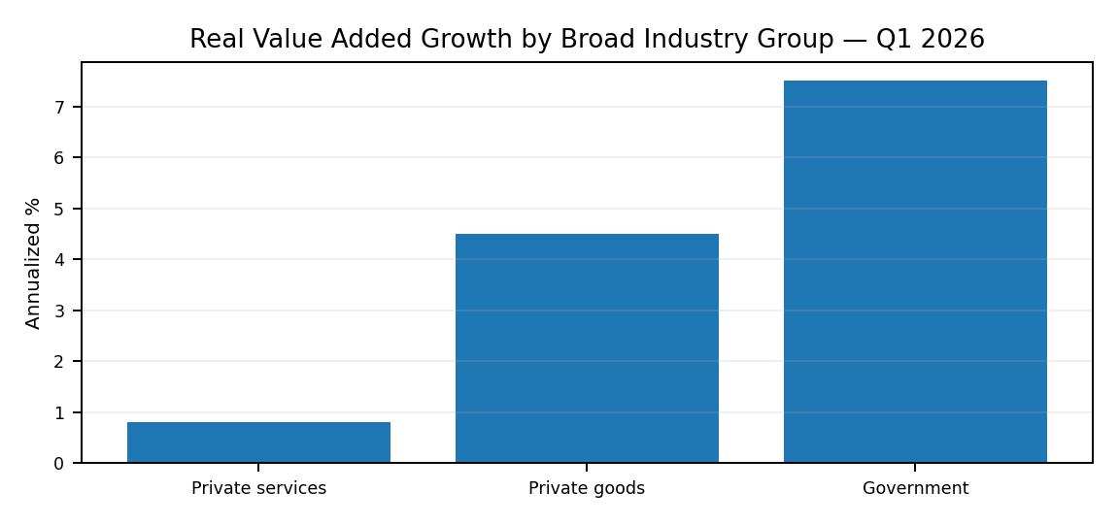 | 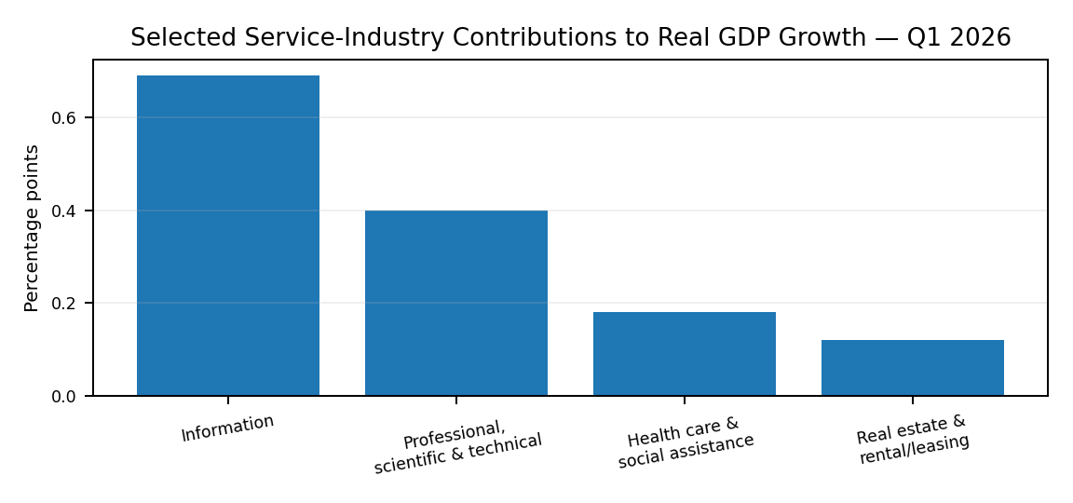
The services economy is not moving evenly across every industry. Aggregate services growth was modest in the first quarter, but information and professional services made unusually strong contributions. That mix suggests the strongest momentum is concentrated in higher-value, technology-linked activities rather than spread uniformly across the sector.
Signal | Latest reading | Period | Interpretation
Private services real value added | +0.8% annualized | Q1 2026 | Positive, but slower than goods and government
Information contribution | +0.69 pp to GDP growth | Q1 2026 | Largest industry contribution
Professional, scientific & technical | +0.40 pp | Q1 2026 | Strong high-value services contribution
ISM Services PMI | 55.4 | Aug 2026 | Services activity expanding
Source: BEA GDP by Industry, Q1 2026; ISM Services PMI, August 2026. BEA Q2 industry data are scheduled for September 30, 2026.
BrandEssence Economic Intelligence | Chapter 10 | Page 32

CHAPTER 10 / SERVICES ECONOMY

33. Services PMI & Business Activity
ISM Services PMI | Demand, Activity, Employment and Prices
Survey data strengthened during the summer. The ISM Services PMI rose to 55.4 in August, while business activity and new orders moved above 60. The one clear weak spot was employment, which remained below the 50 expansion threshold. At the same time, the prices index climbed further, showing that stronger activity is still coming with meaningful cost pressure.
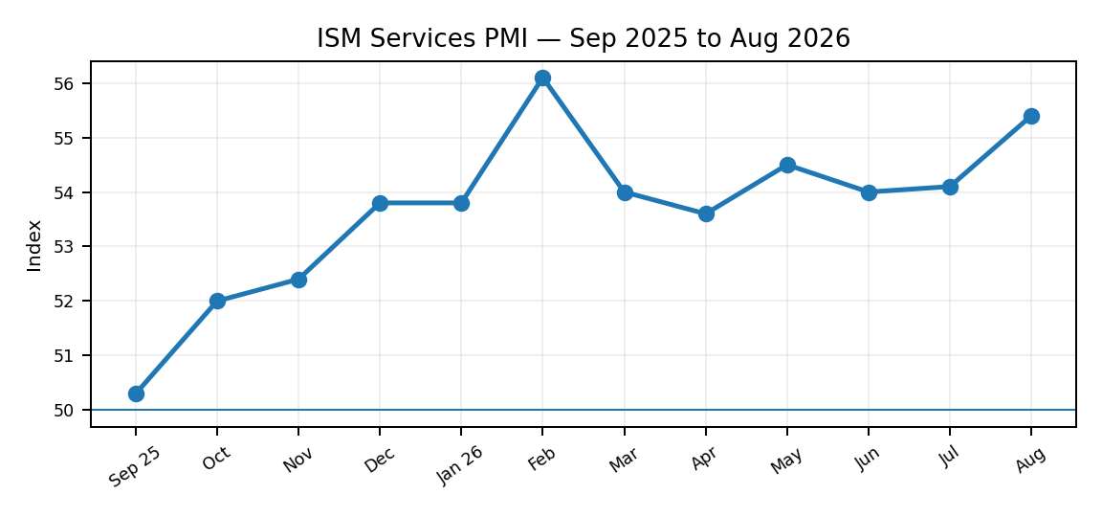 | 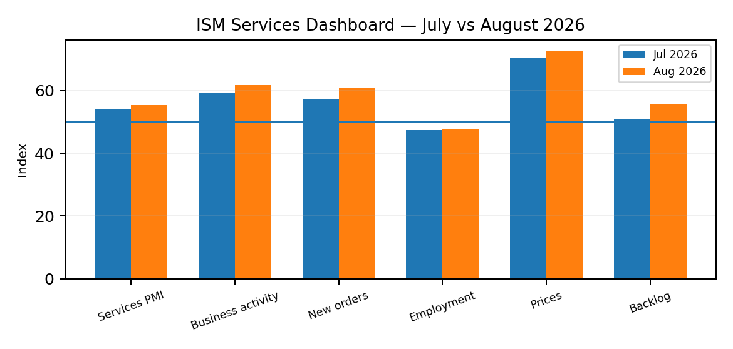
The August survey points to a clear acceleration in service-sector demand. Business activity and new orders are running well above the expansion line, but hiring has not followed the same pattern. The combination of strong demand, weak employment and high prices suggests firms are trying to meet activity with existing capacity while still facing cost pressure.
ISM index | Jul 2026 | Aug 2026 | Direction
Services PMI | 54.1 | 55.4 | Faster expansion
Business Activity | 59.1 | 61.7 | Strong acceleration
New Orders | 57.2 | 60.9 | Demand strengthened
Employment | 47.4 | 47.8 | Still contracting
Prices | 70.3 | 72.6 | Cost pressure increased
Backlog of Orders | 50.9 | 55.6 | Backlogs building
Source: Institute for Supply Management, August 2026 Services PMI Report.
BrandEssence Economic Intelligence | Chapter 10 | Page 33

CHAPTER 10 / SERVICES ECONOMY

34. Technology & Professional Services
High-Value Services | Information, Professional and Knowledge-Based Activity
High-value services are becoming increasingly important to the quality of U.S. growth. Information and professional, scientific and technical services benefit directly from spending on software, cloud infrastructure, AI, research, consulting and specialised business functions. These industries also have strong links to corporate investment, which gives them a different cycle from consumer-facing services.
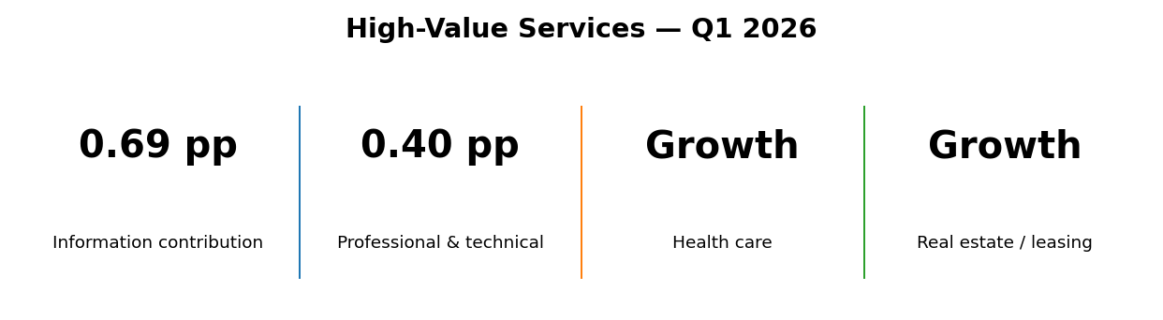
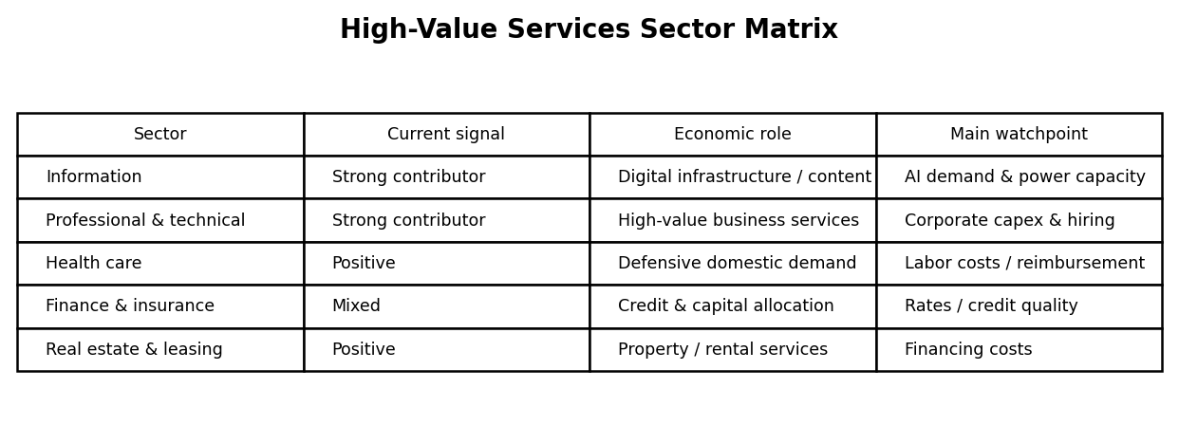
The strongest service-sector contribution is coming from industries tied to knowledge, technology and business investment. Information led industry contributions to GDP growth in the first quarter, with professional and technical services also making a substantial contribution. This supports the view that the U.S. services advantage is increasingly concentrated in high-productivity, high-skill activities.
The sector is not without constraints. ISM's August survey reported GPUs, memory components and labour among items in short supply, while software licensing was among the items rising in price. For technology and professional services, the next phase of growth therefore depends not only on demand, but also on access to computing capacity, specialised workers and supporting infrastructure.
Sector | Current position | Opportunity | Main constraint
Information | Strong | AI, cloud, digital content | Compute and power capacity
Professional / technical | Strong | Consulting, engineering, R&D | Specialised labour
Health care | Positive | Defensive demand, demographics | Labour and cost pressure
Finance & insurance | Mixed | Capital markets, asset management | Rates and credit quality
Real estate / leasing | Positive but rate-sensitive | Rental and property services | Financing costs
Source: BEA GDP by Industry, Q1 2026; ISM Services PMI, August 2026. Sector matrix is BrandEssence interpretation of official industry and survey evidence.
BrandEssence Economic Intelligence | Chapter 10 | Page 34

CHAPTER 11 / INFLATION & PRICE STABILITY

35. Inflation: Current Starting Point
PCE and CPI | Where Inflation Stands Now
Inflation has moved well below the extreme rates seen earlier in the decade, but the final stretch back to price stability remains difficult. The latest readings show headline PCE inflation at 3.7% and CPI inflation at 3.4%. Core measures are lower than headline inflation, yet both remain above the Federal Reserve's 2% objective when judged by PCE.
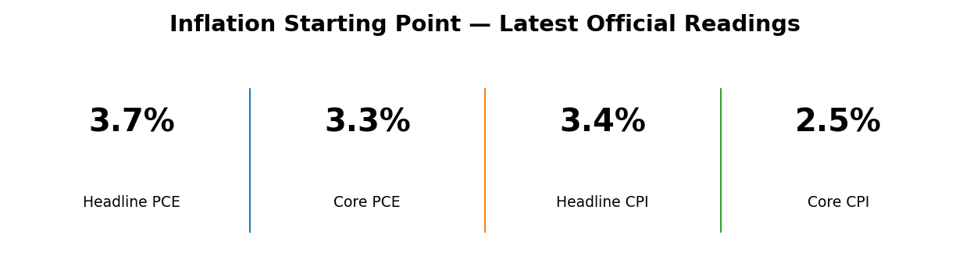
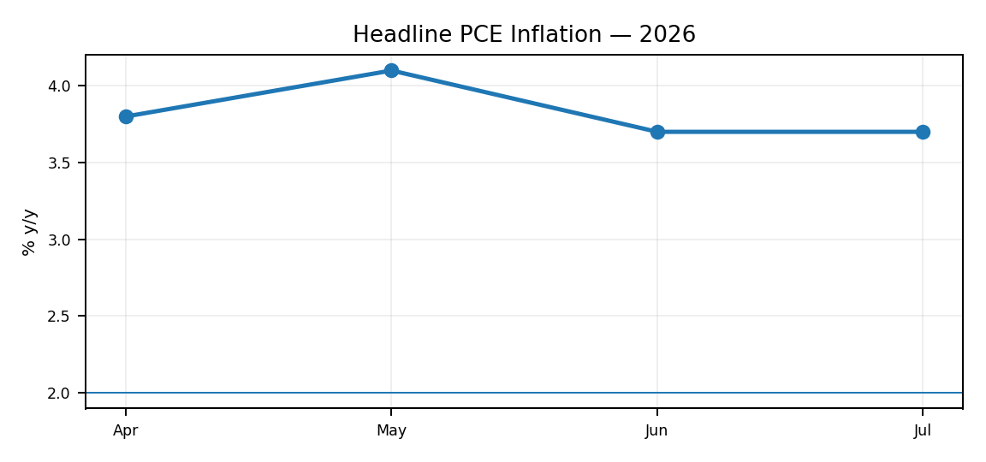 | 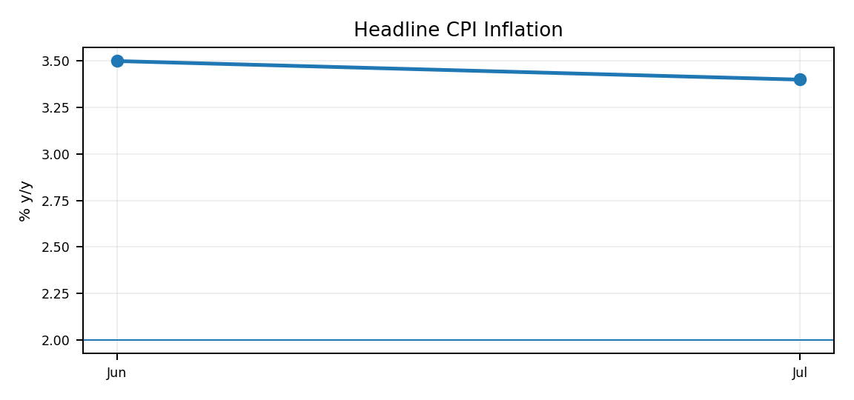
The latest data show disinflation has not stopped, but it has become uneven. CPI eased slightly in July, while PCE inflation remained at 3.7%. The gap between headline and core measures also shows that energy is currently adding more volatility than underlying consumer-price categories.
Measure | Latest y/y | Latest m/m | Period
Headline PCE | 3.7% | +0.2% | Jul 2026
Core PCE | 3.3% | +0.2% | Jul 2026
Headline CPI | 3.4% | +0.1% | Jul 2026
Core CPI | 2.5% | +0.2% | Jul 2026
Source: BEA Personal Income and Outlays, July 2026; BLS Consumer Price Index, July 2026.
BrandEssence Economic Intelligence | Chapter 11 | Page 35

CHAPTER 11 / INFLATION & PRICE STABILITY

36. PCE Inflation
Federal Reserve's Preferred Measure | Headline PCE
The PCE price index is the Federal Reserve's preferred inflation gauge because it covers a broad range of household spending and allows expenditure weights to adjust as consumer behaviour changes. Headline PCE inflation was 3.7% year over year in July, unchanged from June and below the 4.1% reading in May.
Headline PCE cooled from its May increase but has not yet resumed a smooth path toward 2%. The flat 3.7% readings in June and July suggest that the easy part of disinflation has passed. Further improvement will require softer services inflation and less pressure from volatile energy-related categories.
Month | PCE inflation y/y | Monthly price change
Apr 2026 | 3.8% | +0.4%
May 2026 | 4.1% | +0.4%
Jun 2026 | 3.7% | -0.1%
Jul 2026 | 3.7% | +0.2%
Source: U.S. Bureau of Economic Analysis, Personal Consumption Expenditures Price Index and monthly Personal Income and Outlays releases.
BrandEssence Economic Intelligence | Chapter 11 | Page 36

CHAPTER 11 / INFLATION & PRICE STABILITY

37. Core PCE Inflation
Underlying Price Pressure | Excluding Food and Energy
Core PCE strips out food and energy to give a clearer view of persistent price pressure. It eased from 3.4% in May to 3.3% in June and remained at 3.3% in July. The direction is encouraging, but the level is still too high to describe underlying inflation as fully normalised.
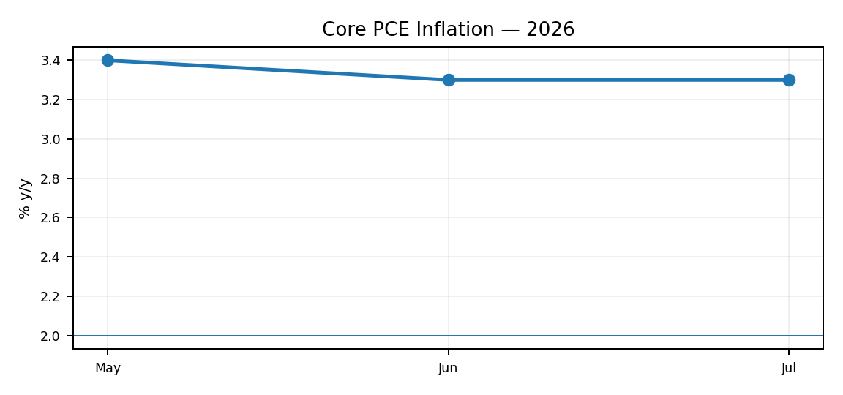
Core PCE is moving in the right direction, but only gradually. The lack of further improvement in July shows why the inflation outlook remains sensitive to services, wages and housing-related costs. A sustained move closer to 2% will probably require several months of softer underlying readings rather than one favourable report.
Month | Core PCE y/y | Core PCE m/m
May 2026 | 3.4% | +0.3%
Jun 2026 | 3.3% | +0.1%
Jul 2026 | 3.3% | +0.2%
Source: BEA Personal Income and Outlays, May–July 2026.
BrandEssence Economic Intelligence | Chapter 11 | Page 37

CHAPTER 11 / INFLATION & PRICE STABILITY

38. CPI Inflation
Consumer Prices | Headline, Core and Major Components
CPI inflation eased to 3.4% in July from 3.5% in June. Core CPI was lower at 2.5%, while energy prices were the main source of headline pressure. Food inflation was 3.0%, shelter 3.2%, and core goods inflation remained comparatively subdued.
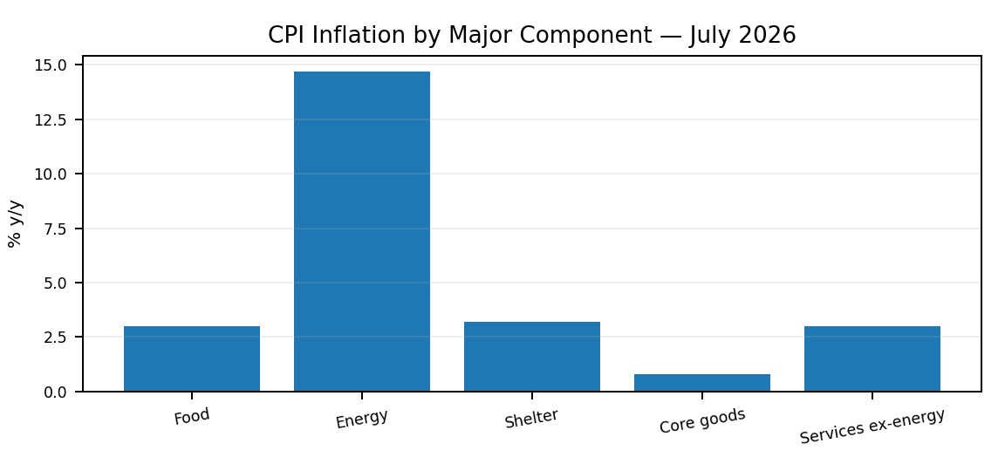
July's CPI mix is unusual because headline inflation is being pushed above core inflation by energy. Core goods are relatively quiet, while shelter and other services remain closer to 3%. That means the inflation problem is no longer broad-based in the same way as at the peak, but it is still not fully resolved.
CPI category | Jul 2026 y/y | Jul 2026 m/m
All items | 3.4% | +0.1%
Core CPI | 2.5% | +0.2%
Food | 3.0% | +0.1%
Energy | 14.7% | -1.5%
Shelter | 3.2% | +0.1%
Services less energy | 3.0% | +0.2%
Core commodities | 0.8% | +0.2%
Source: U.S. Bureau of Labor Statistics, CPI-U, July 2026.
BrandEssence Economic Intelligence | Chapter 11 | Page 38

CHAPTER 11 / INFLATION & PRICE STABILITY

39. Shelter & Housing Inflation
Rent and Owners' Equivalent Rent | Housing Cost Pass-Through
Shelter inflation is finally showing clearer signs of moderation. The shelter index rose only 0.1% in both June and July. In July, rent of primary residence increased 0.3% and owners' equivalent rent increased 0.3%. On a year-over-year basis, shelter and OER were both 3.2%, while primary rent was 2.9%.
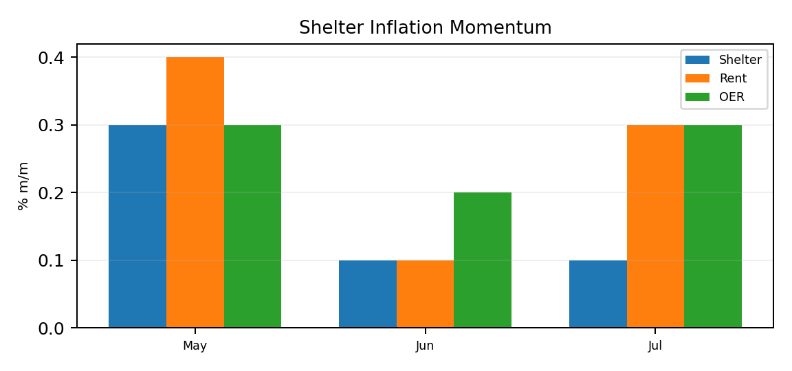
Shelter inflation is no longer accelerating at the pace that made it such a persistent problem earlier in the cycle. Monthly shelter growth has slowed materially, although rent and OER are still rising. If this moderation continues, housing should become less of a drag on the broader disinflation process over the coming quarters.
Housing CPI measure | Jul 2026 y/y | Jul 2026 m/m | Relative importance
Shelter | 3.2% | +0.1% | 35.304%
Rent of primary residence | 2.9% | +0.3% | 7.716%
Owners' equivalent rent | 3.2% | +0.3% | 25.849%
Owners' equivalent rent is not a house-price or mortgage-cost measure. It estimates the rental value of owner-occupied housing, which is why it can move differently from home prices and mortgage rates.
Source: BLS CPI July 2026; BLS methodology for Rent and Rental Equivalence.
BrandEssence Economic Intelligence | Chapter 11 | Page 39

CHAPTER 11 / INFLATION & PRICE STABILITY

40. Inflation Drivers & Risks
Goods, Services, Wages, Energy and Tariffs | What Could Keep Inflation Elevated
The inflation story has become more concentrated. Goods inflation is relatively contained, shelter is cooling, and core inflation is below headline inflation. The largest near-term pressure is energy, while services and wage-sensitive categories remain the main source of persistence. Tariffs are an additional risk because higher import costs can pass through unevenly into goods prices and business margins.
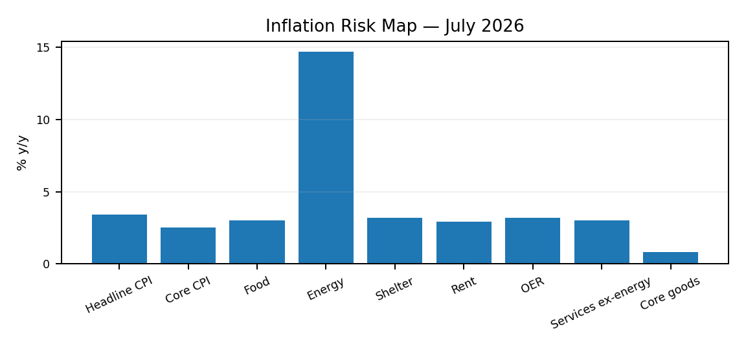
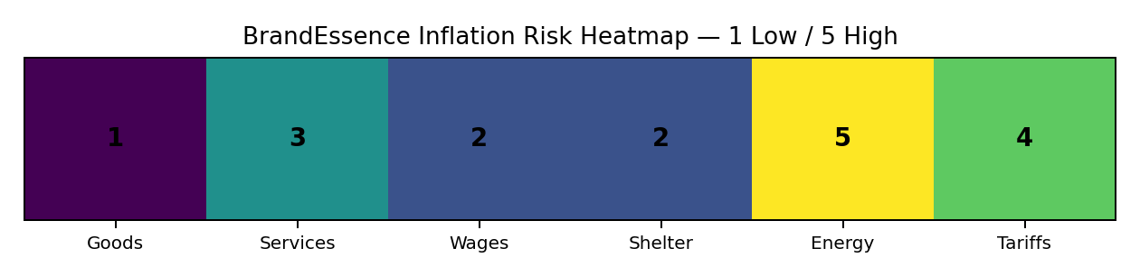
The risk map is no longer dominated by every category at once. Energy is the clearest current upside pressure, while services remain the more persistent underlying concern. Shelter is moving in a better direction and core goods are comparatively benign. The main 2027 risk is that energy or tariff-related cost shocks prevent services disinflation from pulling the overall rate lower.
Driver | Current signal | Risk to 2027 inflation
Core goods | Low inflation | Low
Services ex-energy | Around 3% y/y | Moderate
Shelter | Cooling monthly pace | Moderate / easing
Energy | 14.7% y/y in July | High and volatile
Wages | Still relevant to service costs | Moderate
Tariffs | Potential import-cost pass-through | Elevated uncertainty
Heatmap scores are BrandEssence risk assessments on a 1–5 scale, not official statistical measures. They summarise the direction of current official price data and the main channels that could alter the inflation path.
Source: BEA PCE data; BLS CPI July 2026. Risk scoring and tariff interpretation: BrandEssence Economic Intelligence.
BrandEssence Economic Intelligence | Chapter 11 | Page 40

CHAPTER 12 / FEDERAL RESERVE & MONETARY POLICY

41. Federal Reserve Policy Cycle
Fed Funds Rate | From Tightening to a Restrictive Hold
The Federal Reserve entered 2026 with policy already well below the 2023 peak, but it has not moved into an aggressive easing cycle. The target range has remained at 3.50–3.75% since the beginning of the year. In July, the Committee held rates again as economic activity remained solid and inflation stayed above target.
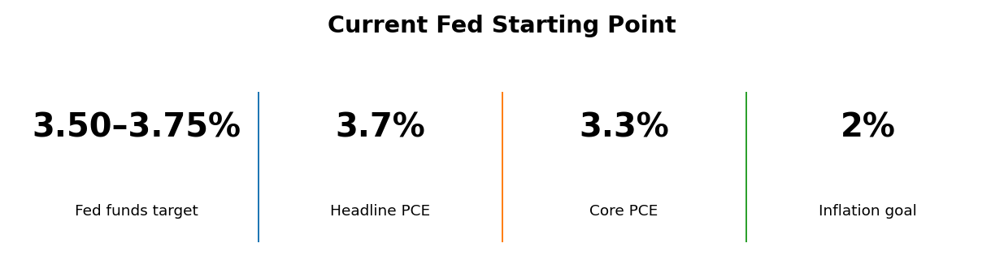
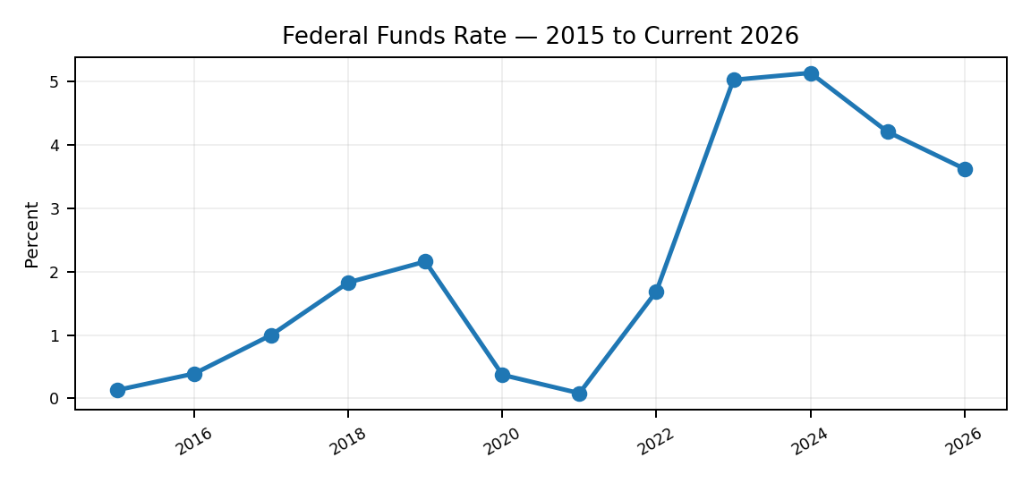
The policy cycle has shifted from rapid tightening to a long restrictive hold. Rates are lower than at the peak, but they are still high enough to restrain interest-sensitive demand. The next move depends less on the level of rates itself and more on whether inflation resumes a convincing decline without a material weakening in employment.
Source: Federal Reserve FOMC statement, July 29, 2026; historical annual effective federal funds rate through 2025. 2026 shown as current target midpoint.
BrandEssence Economic Intelligence | Chapter 12 | Page 41

CHAPTER 12 / FEDERAL RESERVE & MONETARY POLICY

42. FOMC Decision Framework
Employment + Inflation | How the Fed Balances Its Dual Mandate
The Fed's decision is not based on a single inflation print or one payroll report. Policymakers assess inflation relative to the 2% goal, labor-market conditions, growth, financial conditions and the balance of risks. In July, the Committee described activity as solid, job gains as keeping pace with the workforce and inflation as still elevated.
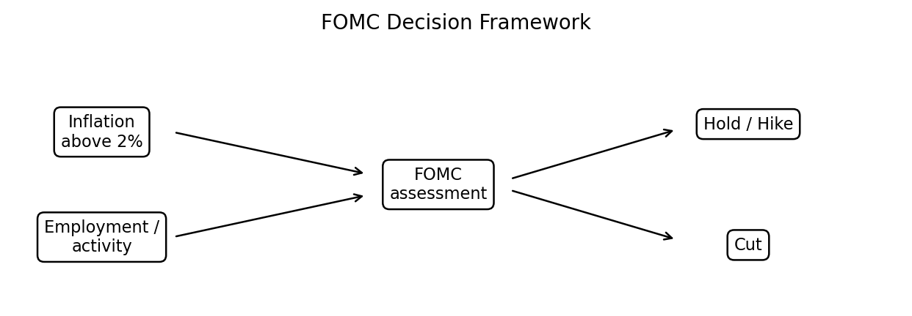
The current reaction function is asymmetric in practice: inflation is still above target, so the Fed needs convincing evidence before easing materially. A weaker labor market would increase the case for cuts, while renewed inflation pressure—especially from supply shocks—would keep a hike scenario alive.
Input | Current policy reading | Likely Fed implication
Inflation | Above 2% goal | Argues for restraint
Labor market | Broadly stable | No urgent need to cut
Growth | Solid | Allows patience
Supply shocks | Energy-related pressure | Raises inflation risk
Financial conditions | Restrictive but functioning | Transmission remains active
Source: Federal Reserve FOMC statement and Monetary Policy Report, July 2026.
BrandEssence Economic Intelligence | Chapter 12 | Page 42

CHAPTER 12 / FEDERAL RESERVE & MONETARY POLICY

43. Fed Dot Plot & Policy Expectations
June 2026 Summary of Economic Projections | FOMC Rate Path
The June dot plot showed a higher expected policy path than the March projections. The median participant projected a 3.8% federal funds rate at the end of 2026, 3.6% in 2027 and 3.4% in 2028, with a 3.1% longer-run estimate. The dots are individual judgments, not a binding Fed promise.
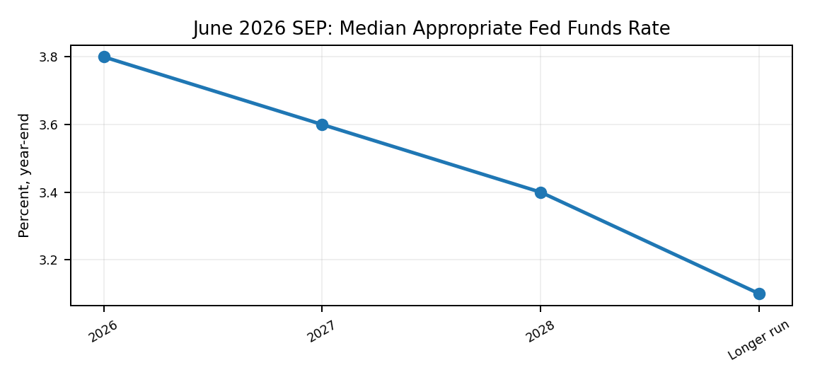 | 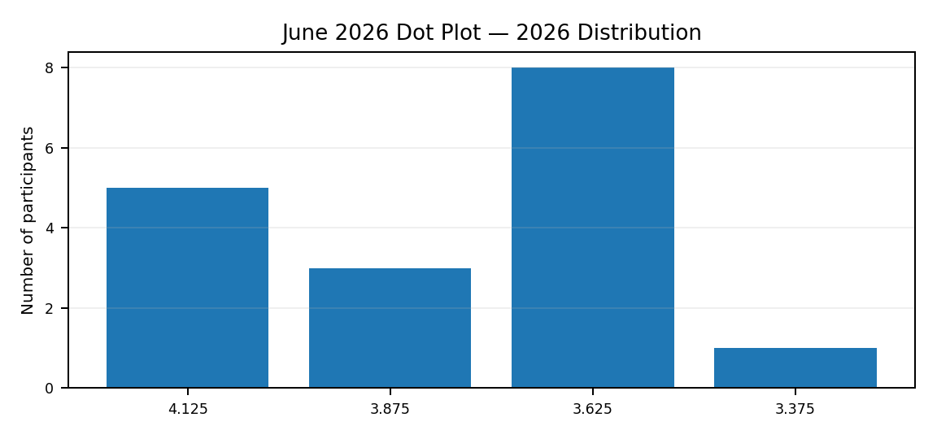
The June projections point to a slow normalization rather than rapid easing. Most participants expected the 2026 year-end rate to remain near the current range, and the median path declines only gradually after that. This is consistent with a Fed that expects inflation to cool, but not quickly enough to justify a return to very low rates.
SEP median | 2026 | 2027 | 2028 | Longer run
Fed funds rate | 3.8% | 3.6% | 3.4% | 3.1%
PCE inflation | 3.6% | 2.3% | 2.0% | 2.0%
Core PCE | 3.3% | 2.5% | 2.1% | —
Unemployment | 4.3% | 4.3% | 4.2% | 4.2%
Source: Federal Reserve, Summary of Economic Projections, June 17, 2026.
BrandEssence Economic Intelligence | Chapter 12 | Page 43

CHAPTER 12 / FEDERAL RESERVE & MONETARY POLICY

44. Real Policy Rate
Restrictiveness | Nominal Policy Rate Adjusted for Inflation
A simple way to judge monetary restrictiveness is to subtract inflation from the nominal policy rate. Using the current target midpoint of 3.625% and July core PCE inflation of 3.3% gives a real-policy-rate proxy of roughly +0.33%. This is a simplified ex-post measure; it is not the same as a forward-looking real rate or the neutral rate.
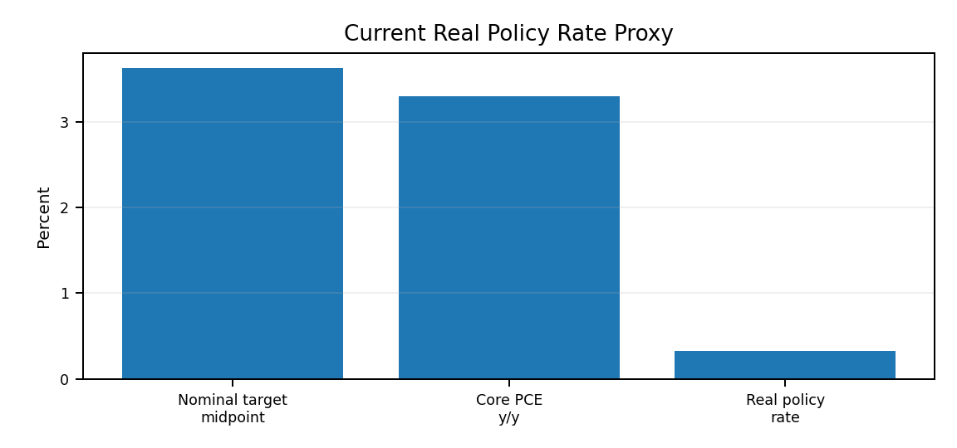
The real policy rate is still positive, which means monetary policy remains restrictive in inflation-adjusted terms. However, the margin is much smaller than it was when nominal rates were above 5%. If inflation falls while the Fed holds nominal rates steady, real policy would automatically become tighter; if inflation rises, the opposite would happen.
Calculation | Value
Fed funds target midpoint | 3.625%
Core PCE inflation, Jul 2026 | 3.3%
Real policy rate proxy | ≈ +0.33%
Formula | Nominal policy rate − core PCE inflation
Source: Federal Reserve target range; BEA core PCE, July 2026. BrandEssence calculation.
BrandEssence Economic Intelligence | Chapter 12 | Page 44

CHAPTER 12 / FEDERAL RESERVE & MONETARY POLICY

45. Monetary Transmission
Fed → Credit → Demand | How Policy Reaches the Economy
Monetary policy works with a lag. A change in the federal funds rate first affects money-market rates and expectations, then moves through Treasury yields, corporate borrowing costs, bank lending, mortgages and asset prices. Those financial conditions influence housing, business investment and household demand before the effect becomes visible in inflation and employment.
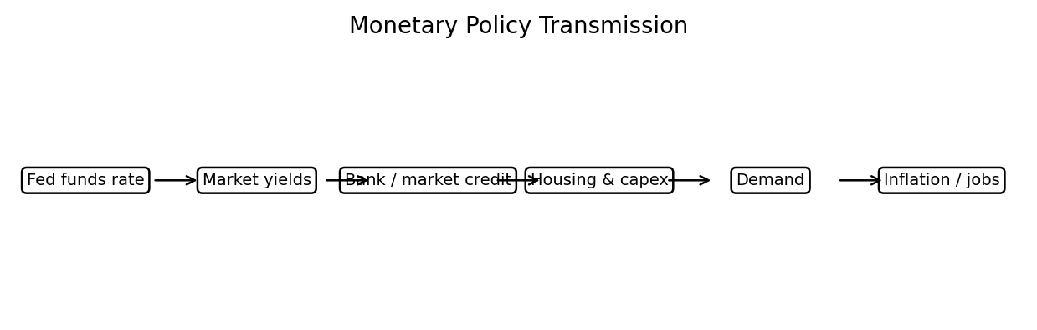
The transmission chain explains why the Fed can hold rates steady and still exert restraint. Earlier rate increases remain embedded in mortgage rates, refinancing costs and corporate hurdle rates. The effect is strongest in sectors that depend heavily on new borrowing, while cash-rich firms and households with fixed-rate debt are less immediately exposed.
Source: Federal Reserve monetary-policy framework and Monetary Policy Report. Diagram is a BrandEssence synthesis of standard transmission channels.
BrandEssence Economic Intelligence | Chapter 12 | Page 45

CHAPTER 12 / FEDERAL RESERVE & MONETARY POLICY

46. Fed Balance Sheet
Assets, Reserves and the Post-QT Operating Framework
The balance-sheet story changed at the end of 2025. The Fed judged reserves to be in the ample range and moved away from balance-sheet runoff toward reserve-management purchases of short-term Treasuries. By early July 2026, total assets were about $6.7 trillion and reserve balances were around $3.1 trillion. The September 3 H.4.1 release reported total assets of $6.737 trillion.
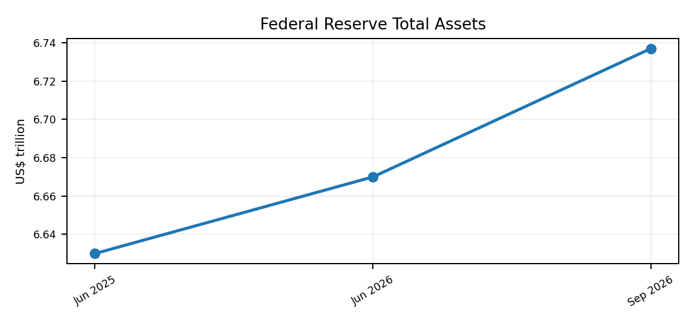
The balance sheet is no longer shrinking in the same way it did during quantitative tightening. Small Treasury-bill purchases are now being used to maintain ample reserves, so a modest increase in total assets should not be interpreted as a return to crisis-style quantitative easing. The objective is money-market implementation, not broad demand stimulus.
Balance-sheet item | Latest / current context
Total Fed assets | $6.737T, Sep. 3 2026
Reserve balances | About $3.1T by early Jul 2026
Treasury-bill purchases | Reserve-management purchases ongoing
Agency principal payments | Reinvested into Treasury bills
Operating objective | Maintain ample reserves
Source: Federal Reserve H.4.1, September 3, 2026; Federal Reserve Monetary Policy Report, July 2026.
BrandEssence Economic Intelligence | Chapter 12 | Page 46

CHAPTER 12 / FEDERAL RESERVE & MONETARY POLICY

47. Fed Policy Scenarios
Hike / Hold / Cut | Decision Tree for 2026–27
The Fed enters the next decision window with three credible paths. A hold remains the central near-term outcome while inflation is above target and growth is solid. A hike becomes more plausible if inflation re-accelerates or supply shocks broaden into underlying prices. Cuts become more likely if inflation cools decisively or labor-market conditions weaken.
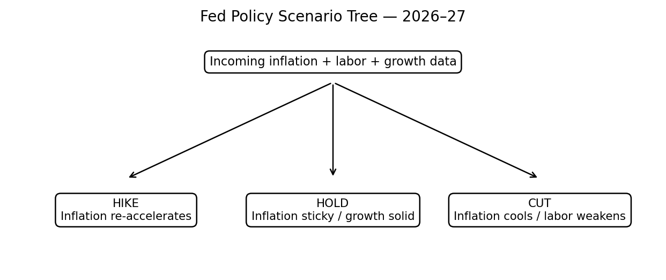
The decision tree is deliberately conditional rather than a point forecast. Current policy and the June SEP favour patience, but the range of outcomes is wider than it looked earlier in the disinflation cycle. For businesses, the practical assumption should be that financing costs stay elevated unless the inflation data improve enough to give the Fed room to ease.
Scenario | Trigger | Policy direction | Business implication
Hike | Inflation re-accelerates / expectations rise | Tighter | Higher funding and valuation pressure
Hold | Inflation sticky, growth and jobs stable | Restrictive plateau | High rates persist
Cut | Inflation cools or labor weakens materially | Easier | Gradual relief to credit-sensitive sectors
These scenarios are BrandEssence decision paths, not official FOMC forecasts. The official June SEP median projected 3.8% at end-2026 and 3.6% at end-2027, but individual outcomes depend on incoming data.
Source: Federal Reserve FOMC July 2026 statement and June 2026 Summary of Economic Projections; scenario framing: BrandEssence Economic Intelligence.
BrandEssence Economic Intelligence | Chapter 12 | Page 47

